Meets ASE Task: (A1-C-2) P-1 Remove, inspect, and/or replace crankshaft vibration damper (harmonic balancer).
Evaluation (Enter number from 4, 3, 2, 1) :_________
Crankshaft Vibration Damper
Name:_____________________________________
Date:_____________
Time on Task:_____________
Make/Model/Year:____________________________________
VIN:_________________________________
Page 114
1. Check service information for the specified inspection and installation procedure.
__________________________________________________________________
__________________________________________________________________
__________________________________________________________________
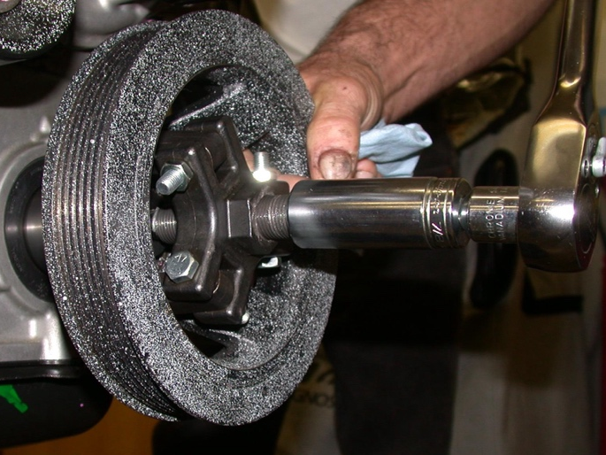
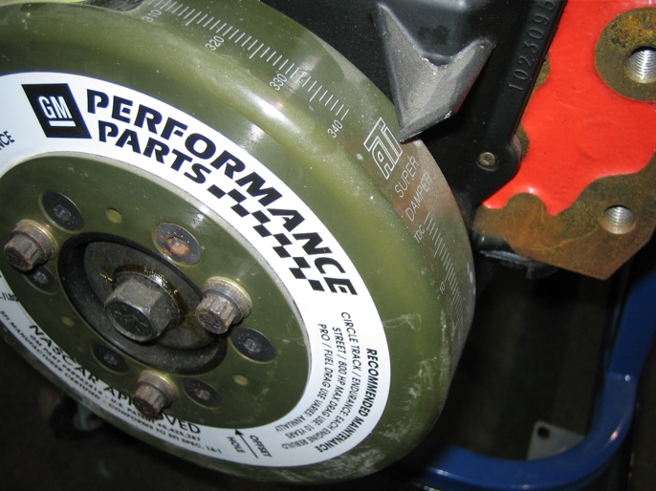
_____ 2. Visually check the condition of the crankshaft vibration damper (harmonic balancer)
including:
a. Rubber connection between the inner and outer rings
b. Nose area for wear from the front seal
OK NOT OK Describe faults: _____________________________
_________________________________________________________________
3. Check service information for the specified torque specifications for the crankshaft
vibration damper retaining bolt. Torque specification = ________________
4. Install the crankshaft vibration damper and tighten the retaining bolt to factory
specifications.

