Meets ASE Task: (A1-C-14) P-2 Inspect auxiliary shaft(s) (balance, intermediate, idler, counterbalance and/or silencer); inspect shaft(s) and support bearings for damage and wear; determine needed action; reinstall and time.

Evaluation (Enter number from 4, 3, 2, 1) :_________
Auxiliary and Balance Shafts
Name:_____________________________________
Date:_____________
Time on Task:_____________
Make/Model/Year:____________________________________
VIN:_________________________________
Page 113
1. Check service information to determine the specified checking procedure and
specifications for auxiliary shafts and bearings.

__________________________________________________________________
__________________________________________________________________
__________________________________________________________________

2. Visually check the auxiliary shaft(s) and bearings for damage and excessive wear.

OK NOT OK Describe faults: _____________________________
_________________________________________________________________
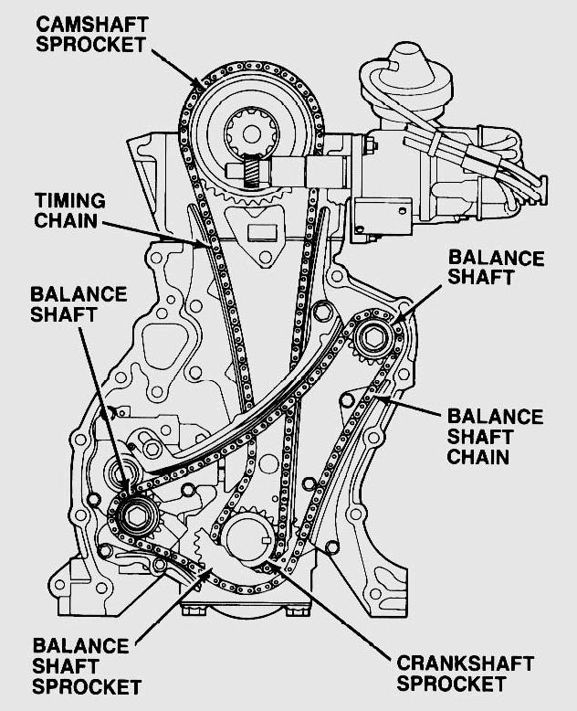

3. Based on visual inspection and specified
checking procedures, what is the
needed action?

_____________________________
_____________________________
_____________________________
_____________________________

4. Check service information for the
correct timing during the installation of
counter balance or silencer shafts.
Show instructor the correctly installed
shaft.
Instructor’s OK _________

