Meets ASE Task: (A1-C-8) P-2 Inspect crankshaft for straightness, journal damage, keyway damage, thrust flange and sealing surface condition, and visual surface cracks; check oil passage condition; measure end play and journal wear; check crankshaft position sensor reluctor ring (where applicable); determine needed action.

Evaluation (Enter number from 4, 3, 2, 1) :_________
Crankshaft Inspection
Name:_____________________________________
Date:_____________
Time on Task:_____________
Make/Model/Year:____________________________________
VIN:_________________________________
Page 111
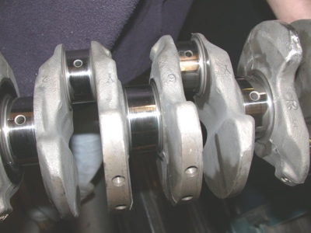
1. Check service information for the crankshaft specifications and
inspection procedure.

_______________________________________________

2. Inspect crankshaft for straightness. OK NOT OK

3. Check crankshaft journals for damage. OK NOT OK

4. Check the crankshaft keyway for damage. OK NOT OK

5. Check the crankshaft thrust flange and sealing surfaces condition.

OK NOT OK

6. Visually check the crankshaft for cracks. OK NOT OK

7. Measure crankshaft journals and determine if worn.

Main bearing journals: _____ _____ _____ _____ _____ _____ _____

Rod bearing journals: _____ _____ _____ _____ _____ _____

8. Based on the results of the inspection and measurement of the crankshaft, what is the
needed action?

__________________________________________________________________
__________________________________________________________________

