**Meets ASE Task:** (A1-B-7) P-2 Inspect and measure camshaft bearings for wear, damage, out-of-round, and alignment; determine needed action.

Evaluation (Enter number from 4, 3, 2, 1) :_________

**Camshaft Bearings**

Name:_____________________________________

Date:_____________

Time on Task:_____________

Make/Model/Year:____________________________________

VIN:_________________________________

Page 110

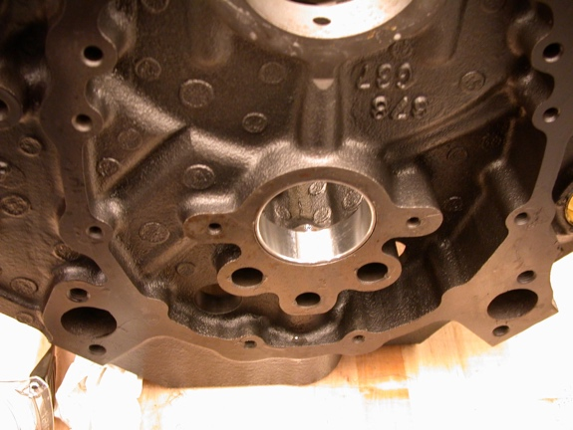 **1.** Check service information to determine the

specified procedures and specifications

for measuring camshaft bearings.

__________________________________

__________________________________

**2.** Visually inspect the camshaft bearings for

damage and excessive wear.

**OK**  **NOT OK**

Describe faults: ____________________________________________________

_________________________________________________________________

**3.** Measure the camshaft bearings and compare to specifications.

Front bearing Diameter = ____________ Specifications = ____________

Out of round = ____________ Specifications = ____________

Second bearing Diameter = ____________ Specifications = ____________

Out of round = ____________ Specifications = ____________

Third bearing Diameter = ____________ Specifications = ____________

Out of round = ____________ Specifications = ____________

Fourth bearing Diameter = ____________ Specifications = ____________

Out of round = ____________ Specifications = ____________

Fifth bearing Diameter = ____________ Specifications = ____________

Out of round = ____________ Specifications = ____________

**4.** Based on the inspection and measurements of the camshaft bearings, what is the

needed action?

________________________________________________________________

________________________________________________________________