1. Drill a hole in a piece of metal about ¼ inch thick and then thread it using a tap.

Meets ASE Task: (A0-B-6) Perform thread repair. Perform common fastener and thread repair, including removing broken bolts, restoring internal and external threads, and repairing internal threads with a thread insert.

**Thread Repair**

Name:_____________________________________

Date:_____________

Time on Task:_____________

Make/Model/Year:____________________________________

VIN:_________________________________

Evaluation (Enter number from 4, 3, 2, 1) :_________

Page 11

Install a bolt into the thread hole and either break it off or cut the bolt flush with the

surface.

Drill size ___________________

Tap Size ___________________ **Instructor OK _________________**

2. Remove the broken off bolt using an easy out or other tool.

**Instructor OK _________________**

3. Using an old engine block, drill out one threaded hole in the block and install a

threaded insert, following the instructions that came with the thread insert kit.

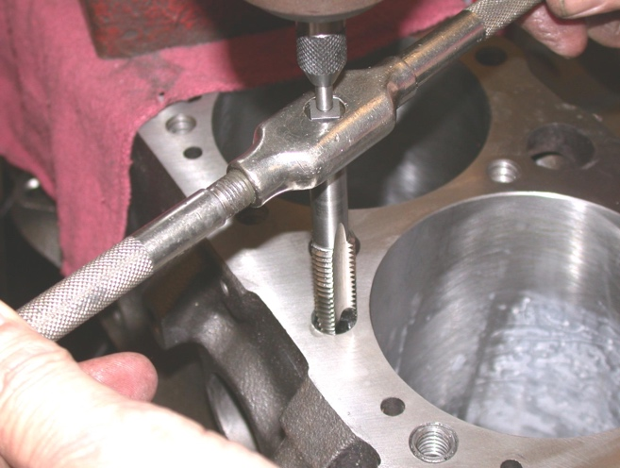 **Instructor OK _________________**