Meets ASE Task: (A1-C-12) P-2 Determine piston-to-bore clearance.

Evaluation (Enter number from 4, 3, 2, 1) :_________
Piston-to-Bore Clearance
Name:_____________________________________
Date:_____________
Time on Task:_____________
Make/Model/Year:____________________________________
VIN:_________________________________
Page 109
1. Check service information for the recommended procedures to follow to determine the
piston-to-bore clearance. Describe the specified procedures. ____________________
__________________________________________________________________
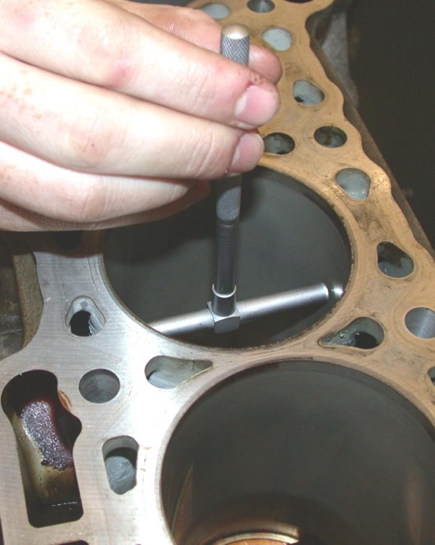
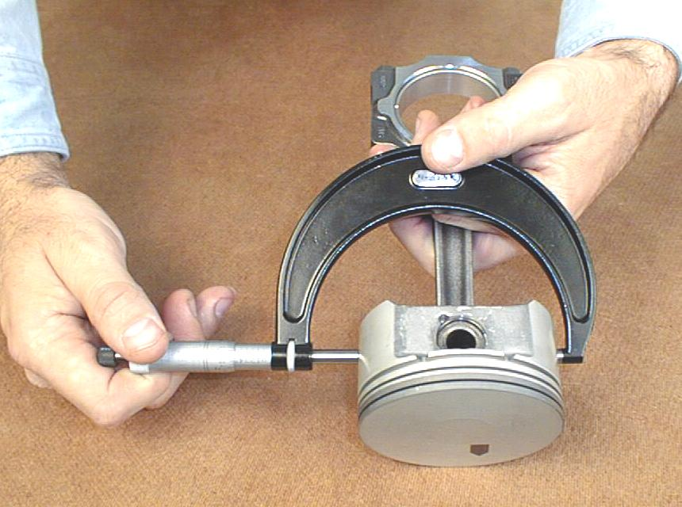

2. What is the specified piston-to-bore clearance? ______________________
3. Measure the piston-to-bore clearance on all cylinders:
Cylinder #1 ____________ OK NOT OK
Cylinder #2 ____________ OK NOT OK
Cylinder #3 ____________ OK NOT OK
Cylinder #4 ____________ OK NOT OK
Cylinder #5 ____________ OK NOT OK
Cylinder #6 ____________ OK NOT OK
Cylinder #7 ____________ OK NOT OK
Cylinder #8 ____________ OK NOT OK

