Meets ASE Task: (A1-C-7) P-2 Inspect and measure camshaft bearings for wear, damage, out-of-round, and alignment; determine needed action.
Evaluation (Enter number from 4, 3, 2, 1) :_________
Camshaft Bearing Inspection
Name:_____________________________________
Date:_____________
Time on Task:_____________
Make/Model/Year:____________________________________
VIN:_________________________________
Page 108
1. Check service information for the exact procedures and specifications when checking
camshaft bearings.
a. Recommended procedures: _________________________________________
____________________________________________________________
b. Specifications: ___________________________________________________
____________________________________________________________
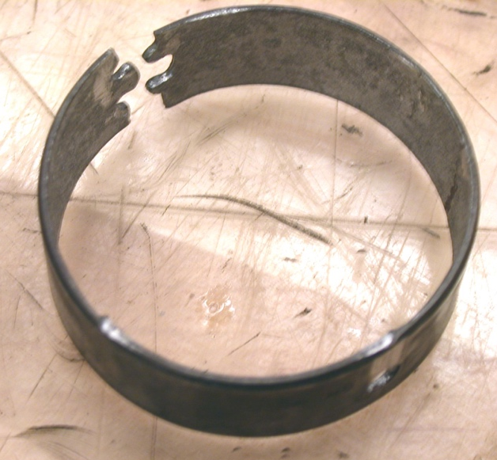
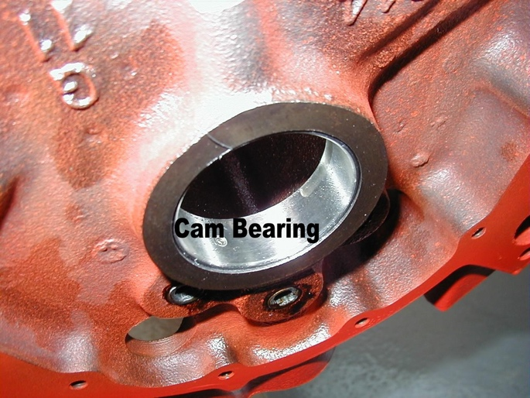

2. Based on the inspection and measurements,
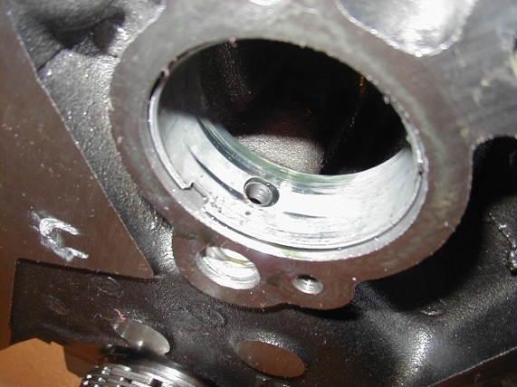
what is the needed action?
__________________________________
__________________________________
__________________________________
__________________________________
__________________________________

