Meets ASE Task: (A1-C-6) P-2 Perform deglazing and cleaning of cylinder walls.
Evaluation (Enter number from 4, 3, 2, 1) :_________
Cylinder Bore Deglazing
Name:_____________________________________
Date:_____________
Time on Task:_____________
Make/Model/Year:____________________________________
VIN:_________________________________
Page 107
A deglazing hone is designed to remove the hard surface glaze in the cylinder. A deglazing hone is flexible so that it can follow the shape of the cylinder and cannot be used to straighten the cylinder.

1. Completely disassemble the engine block.

2. Measure the cylinder for out-of round.

Maximum out-of-round specification = ___________
Actual out-of-round:
cylinder #1 _________ cylinder #5 __________
cylinder #2 _________ cylinder #6 __________
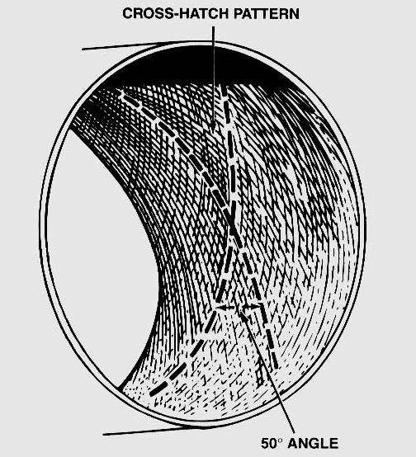
cylinder #3 _________ cylinder #7 __________
cylinder #4 _________ cylinder #8 __________

OK NOT OK

3. Measure the cylinder for taper.

Specifications = ___________
Actual cylinder taper:
cylinder #1 _________ cylinder #5 __________
cylinder #2 _________ cylinder #6 __________
cylinder #3 _________ cylinder #7 __________
cylinder #4 _________ cylinder #8 __________

OK NOT OK

4. If both cylinder taper and out-of-round measurements are within factory
specifications, select a deglazing hone of the proper size with a 220 or 280 grit stone.

5. Install the hone into an electric drill motor and hone the cylinders being sure to use the
proper coolant/lubricant specified by the manufacturer of the hone.

6. After honing, be sure to wash the block with soap or detergent to thoroughly clean all
of the honing grit from the block.

