Meets ASE Task: (A1-C-5) P-2 Inspect and measure cylinder walls/sleeves for damage, wear, and ridges; determine needed action.
Evaluation (Enter number from 4, 3, 2, 1) :_________
Cylinder Bore Measurement
Name:_____________________________________
Date:_____________
Time on Task:_____________
Make/Model/Year:____________________________________
VIN:_________________________________
Page 106
1. Cylinder bore specifications = _______________________

2. Measured cylinder bore:

Cylinder #1 __________ Cylinder #5 ____________
Cylinder #2 __________ Cylinder #6 ____________
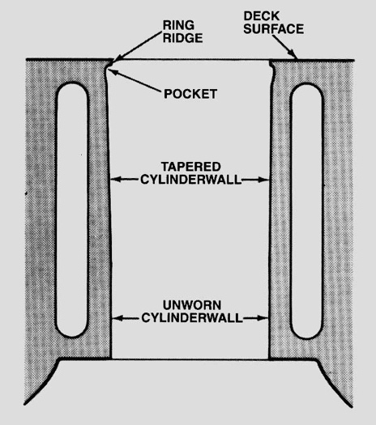
Cylinder #3 __________ Cylinder #7 ____________
Cylinder #4 __________ Cylinder #8 ____________

OK NOT OK

3. Maximum out-of-round specification = ___________

4. Measured out-of-round:

Cylinder #1 __________ Cylinder #5 ____________
Cylinder #2 __________ Cylinder #6 ____________
Cylinder #3 __________ Cylinder #7 ____________
Cylinder #4 __________ Cylinder #8 ____________

OK NOT OK

5. Maximum taper specification = _________________

6. Measured taper:

Cylinder #1 __________ Cylinder #5 ____________
Cylinder #2 __________ Cylinder #6 ____________
Cylinder #3 __________ Cylinder #7 ____________
Cylinder #4 __________ Cylinder #8 ____________

OK NOT OK

7. What is the needed action? ______________________________________________

