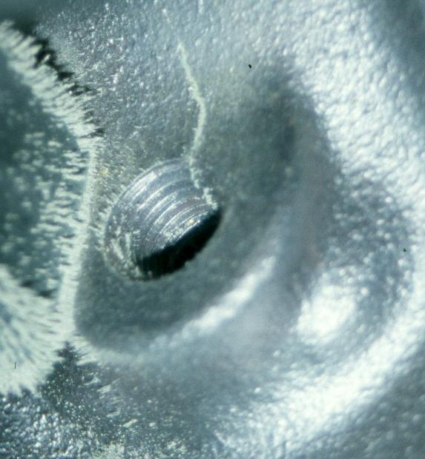
Meets ASE Task: (A1-C-4) P-2 Inspect engine block for visible cracks, passage condition, core and gallery plug condition, and surface warpage; determine needed action.
Evaluation (Enter number from 4, 3, 2, 1) :_________
Engine Block Inspection
Name:_____________________________________
Date:_____________
Time on Task:_____________
Make/Model/Year:____________________________________
VIN:_________________________________
Page 105
1. Visually check the engine block for cracks.

OK NOT OK

describe fault(s) _____________________________
___________________________________________
___________________________________________
___________________________________________

2. Inspect block passages (coolant and oil) for condition.

OK NOT OK describe fault(s) _____________________________
________________________________________________

3. Inspect core and gallery plugs condition for signs of leakage.

OK NOT OK describe fault(s) _____________________________
________________________________________________

4. Check surface for warpage:

A. Specification for maximum allowable warpage = __________

B. Measured amount of warpage = __________

5. What is the needed action? ______________________________________________

_________________________________________________________________

