Meets ASE Task: (A1-A-1) P-1 Research vehicle service information such as fluid type, internal combustion engine operation, vehicle service history, service precautions, technical service bulletins, and recalls including vehicles equipped with advanced driver assistance systems (ADAS).

Evaluation (Enter number from 4, 3, 2, 1) :_________
Cylinder Block Specification/Measurement
Name:_____________________________________
Date:_____________
Time on Task:_____________
Make/Model/Year:____________________________________
VIN:_________________________________
Page 104
1. Measure the main bearing bores (specification: ___________):

#1 _____ #2 _____ #3 _____ #4 _____ #5 _____ #6 _____ #7 _____

2. Specification for maximum out-of-round: ___________

3. Measure the cylinder bores for out-of-round:

#1 #2 #3 #4 #5 #6 #7 #8

Out-of-round ____ ____ ____ ____ ____ ____ ____ ____

OK NOT OK

4. Specification for maximum cylinder taper: ________________

5. Measure the cylinder bores for taper:

#1 #2 #3 #4 #5 #6 #7 #8

Taper ___ ____ ____ ____ ____ ____ ____ ____

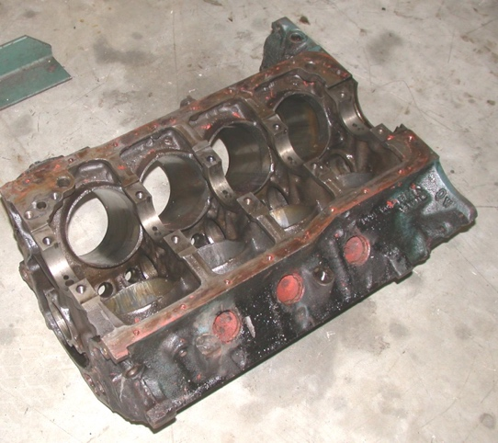
OK NOT OK

6. Bore or hone cylinders as needed Yes No

7. Specification for flatness of block deck __________

8. Measure flatness of the block deck ___________

OK NOT OK

