Meets ASE Task: (A1-C-13) P-2 Inspect, measure, and install piston rings.

Evaluation (Enter number from 4, 3, 2, 1) :_________
Piston Rings
Name:_____________________________________
Date:_____________
Time on Task:_____________
Make/Model/Year:____________________________________
VIN:_________________________________
Page 103
Piston rings should be fitted to each cylinder of the engine. The end gap of the rings is critical for best engine operation.

1. Determine the following specifications for the engine being serviced:

Ring end gap = _________ (usually 0.004” per inch of bore)
Ring side clearance = __________ (usually 0.001” to 0.003”)

2. Select the top compressing ring and install it into the cylinder. Use a piston inserted
upside down into the top of the bore to position the ring squarely in the cylinder.
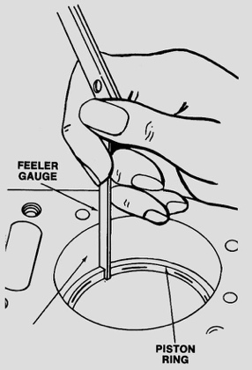
3. Use a feeler (thickness) gauge to measure the ring end gap:

Ring end gap = ___________
OK NOT OK

4. If the gap is less than specified, use a file or ring file tool to
increase the end gap until the specified gap is obtained.

5. Repeat the procedure for the second compression ring.

6. Repeat the procedure for all other rings and cylinders.

7. Before installing the rings on the piston, be sure that there is the specified side
clearance by inserting the piston ring backward into the piston ring groove and
measuring the side clearance with a feeler gauge.

Actual side clearance = _________________

OK NOT OK

