Meets ASE Task: (A1-C-11) P-2 Inspect and measure piston skirts and ring leads; determine needed action.

Evaluation (Enter number from 4, 3, 2, 1) :_________
Piston Inspection and Measurement
Name:_____________________________________
Date:_____________
Time on Task:_____________
Make/Model/Year:____________________________________
VIN:_________________________________
Page 102
1. Check service information for the specified measurements and inspection procedures.
State recommended procedures. __________________________________________
_________________________________________________________________
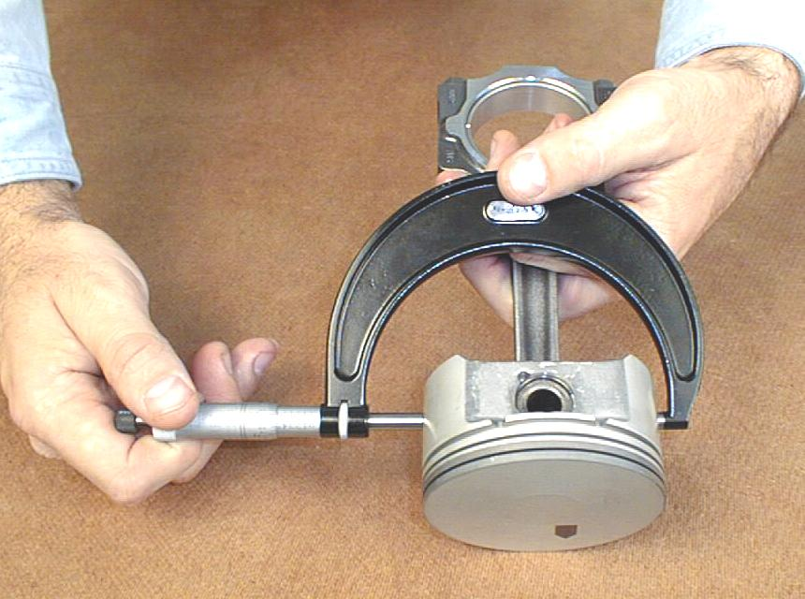
_________________________________________________________________
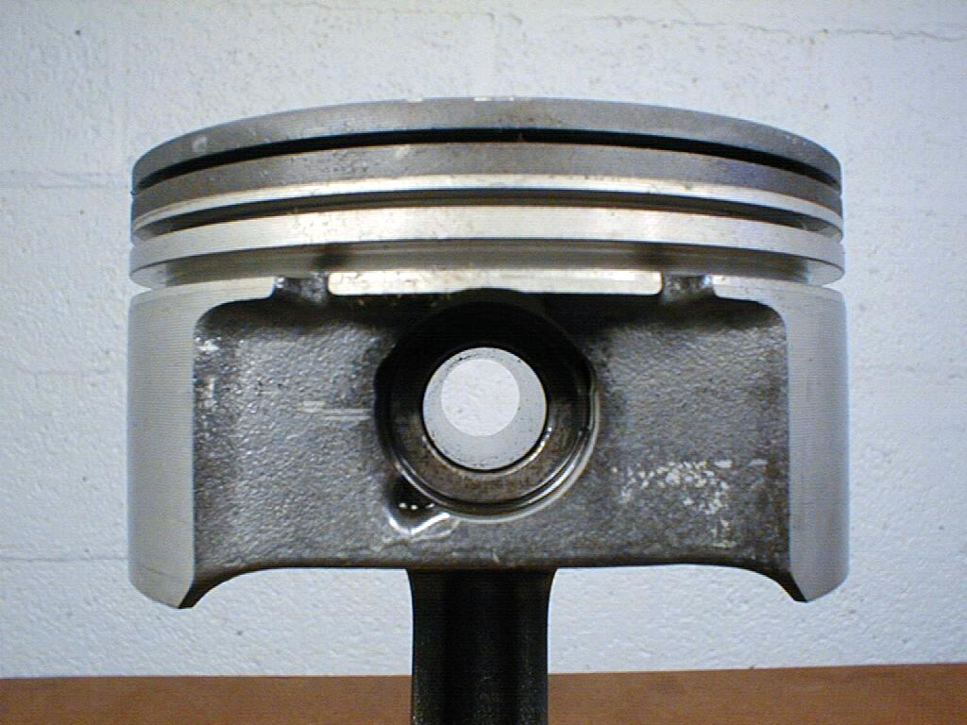

2. What is the specified piston skirt size? Measure and record the piston skirt diameter.
Piston cylinder #1 = __________ Piston cylinder #5 = __________
Piston cylinder #2 = __________ Piston cylinder #6 = __________
Piston cylinder #3 = __________ Piston cylinder #7 = __________
Piston cylinder #4 = __________ Piston cylinder #8 = __________
3. Based on the measurement and the inspection, what is the needed action? __________
__________________________________________________________________
__________________________________________________________________
__________________________________________________________________

