Meets ASE Task: (A1-C-10) P-2 Identify piston and bearing wear patterns that connecting rod alignment and main bearing bore problems; determine needed action.

Evaluation (Enter number from 4, 3, 2, 1) :_________
Piston and Bearing Wear Patterns
Name:_____________________________________
Date:_____________
Time on Task:_____________
Make/Model/Year:____________________________________
VIN:_________________________________
Page 101
1. Check service information to determine procedures and specifications for connecting
rod and main bearing bore alignment.
__________________________________________________________________
__________________________________________________________________
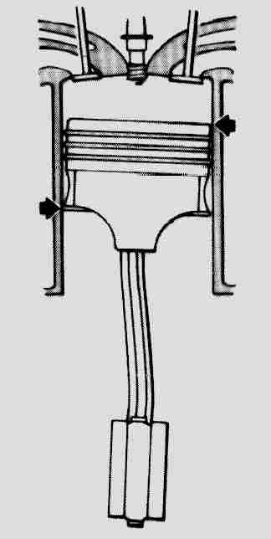
2. Visually inspect the piston skirts for diagonal wear, which could indicate a
bent connecting rod.

OK NOT OK

3. Visually inspect the connecting rod bearings for abnormal wear patterns.

OK NOT OK Describe faults: _____________________
__________________________________________________________

4. Visually inspect the main bearings for abnormal wear patterns.

OK NOT OK Describe faults: _____________________________
__________________________________________________________________

5. Using the specified procedure and equipment, check the connecting rods for proper alignment.

OK NOT OK Describe faults: _____________________________
__________________________________________________________________

6. Using the specified procedure and equipment, check the main bearing bore for proper alignment.

OK NOT OK Describe faults: _____________________________
__________________________________________________________________

