Meets ASE Task: (A1-C-1) P-1 Identify engine block assembly components and configurations.

Evaluation (Enter number from 4, 3, 2, 1) :_________
Connecting Rod Specification/Measurement
Name:_____________________________________
Date:_____________
Time on Task:_____________
Make/Model/Year:____________________________________
VIN:_________________________________
Page 100
1. Type of connecting rod.

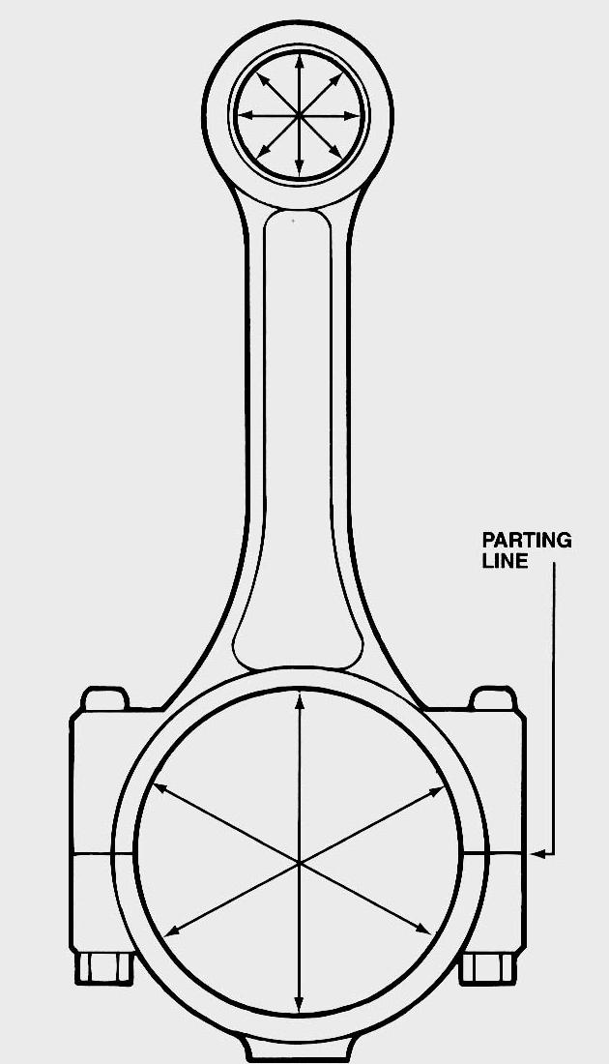
forged (wide parting line)

cast (narrow parting line)

powdered metal (smooth appearance)

2. Is the rod equipped with an oil squirt hole near the big
end to help lubricate the cylinder well and piston pin?

Yes No

3. Type of piston pin.

press fit in the rod

full floating (uses piston pin retainers)

4. Piston pin clearance specification: __________________

5. Measured piston pin clearance in the piston: __________________

OK NOT OK

6. Connecting rod big end diameter specification: ___________________

7. Measure the connecting rod big end diameter: ____________________

OK NOT OK

