Oscilloscope
Meets ASE Task: (A6-A-11) P-2, (A8-B-7) P-2 Diagnose electrical and electronic concerns using an oscilloscope; determine the needed action.

Name _______________________________ Date ___________ Time on Task __________

Make/Model/Year _________________ VIN ________________ Evaluation: 4 3 2 1

_____ 1. Check service information for the recommended usage of an oscilloscope to diagnose
electrical or electronic concerns. Describe the tests recommended. _______________
__________________________________________________________________
__________________________________________________________________
_____ 2. According to service information, which system can/should be tested using an
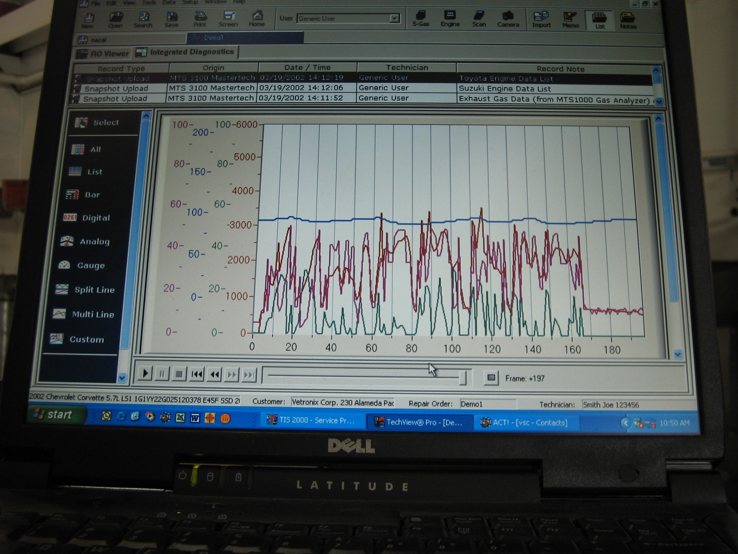
oscilloscope? (Check all that apply.)
____ Wheel speed sensor
____ Crankshaft position sensor
____ Camshaft position sensor
____ Secondary ignition
____ Serial data communication circuits
____ Audio circuits
____ Other (describe) ______________
____________________________
_____ 3. Which system(s) was tested using an oscilloscope? ___________________________
_________________________________________________________________
_________________________________________________________________
_____ 4. Based on the test results, what is the needed action? __________________________
_________________________________________________________________
_________________________________________________________________
_________________________________________________________________

