Refrigerant Handling Equipment
Meets ASE Task: (A7-E-1) P-1 Perform correct use and maintenance of refrigerant handling equipment.

Name _______________________________ Date ___________ Time on Task __________

Make/Model/Year _________________ VIN ________________ Evaluation: 4 3 2 1

_____ 1. What brand and type of refrigerant handling equipment is being used (describe)?
____________________________________________________________________
____________________________________________________________________
____________________________________________________________________
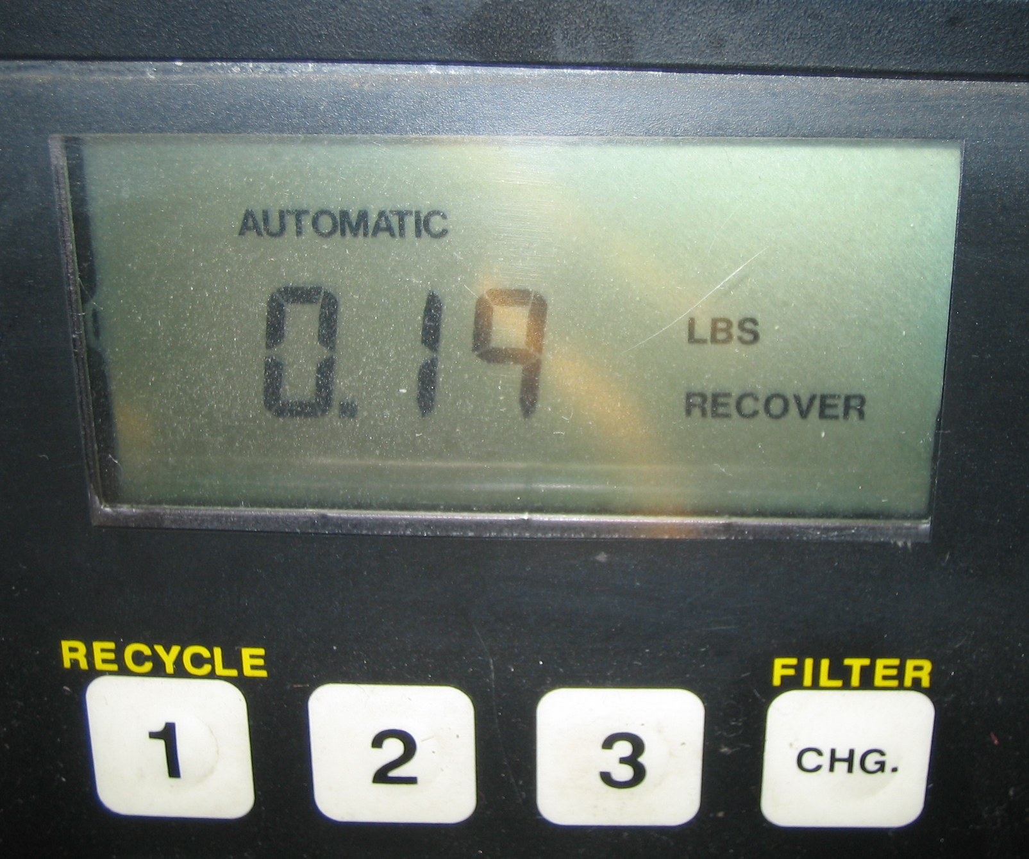

_____ 2. Check the instructions for the equipment and list the maintenance items that should be
performed. ______________________________________________________________
____________________________________________________________________
____________________________________________________________________
_____ 3. Check the instructions and describe how to properly use the refrigerant handling
equipment. _____________________________________________________________
____________________________________________________________________
___________________________________________________________________

