A/C Hoses and Lines
Meets ASE Task: (A7-B-6) P-2 Remove and inspect A/C hoses and lines, O-rings, seals, and service valve.

Name _______________________________ Date ___________ Time on Task __________

Make/Model/Year _________________ VIN ________________ Evaluation: 4 3 2 1

_____ 1. Check service information for the specified procedure and requirements when
inspecting A/C hoses and lines. Describe the specified procedure. _______________
__________________________________________________________________
__________________________________________________________________

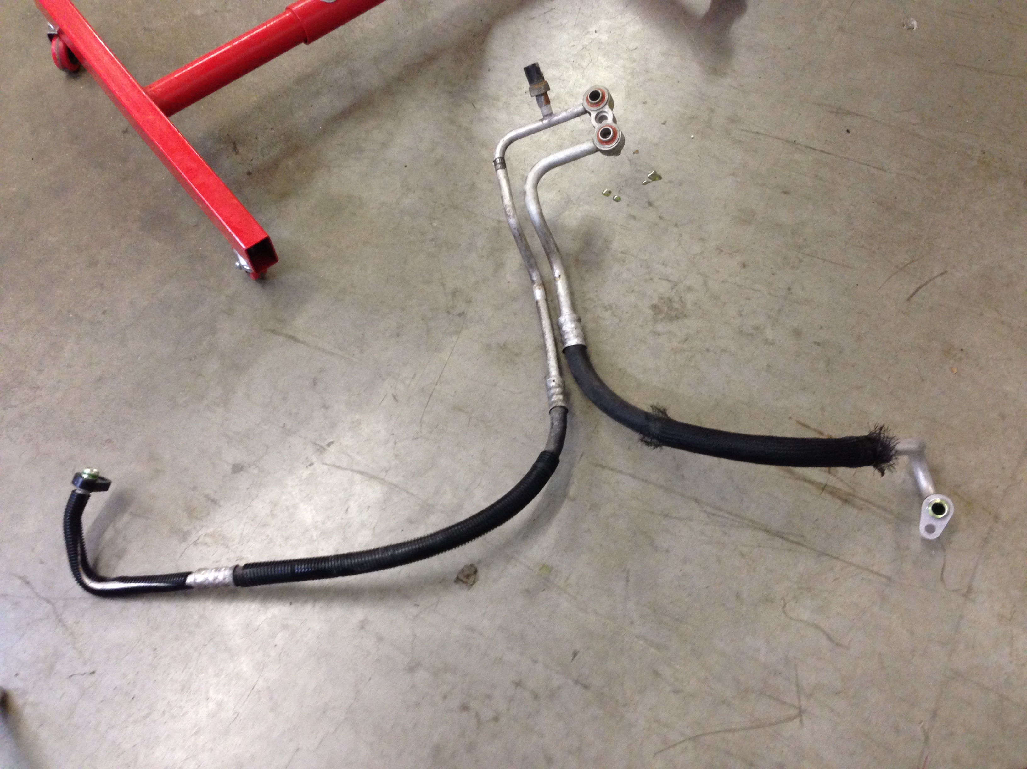
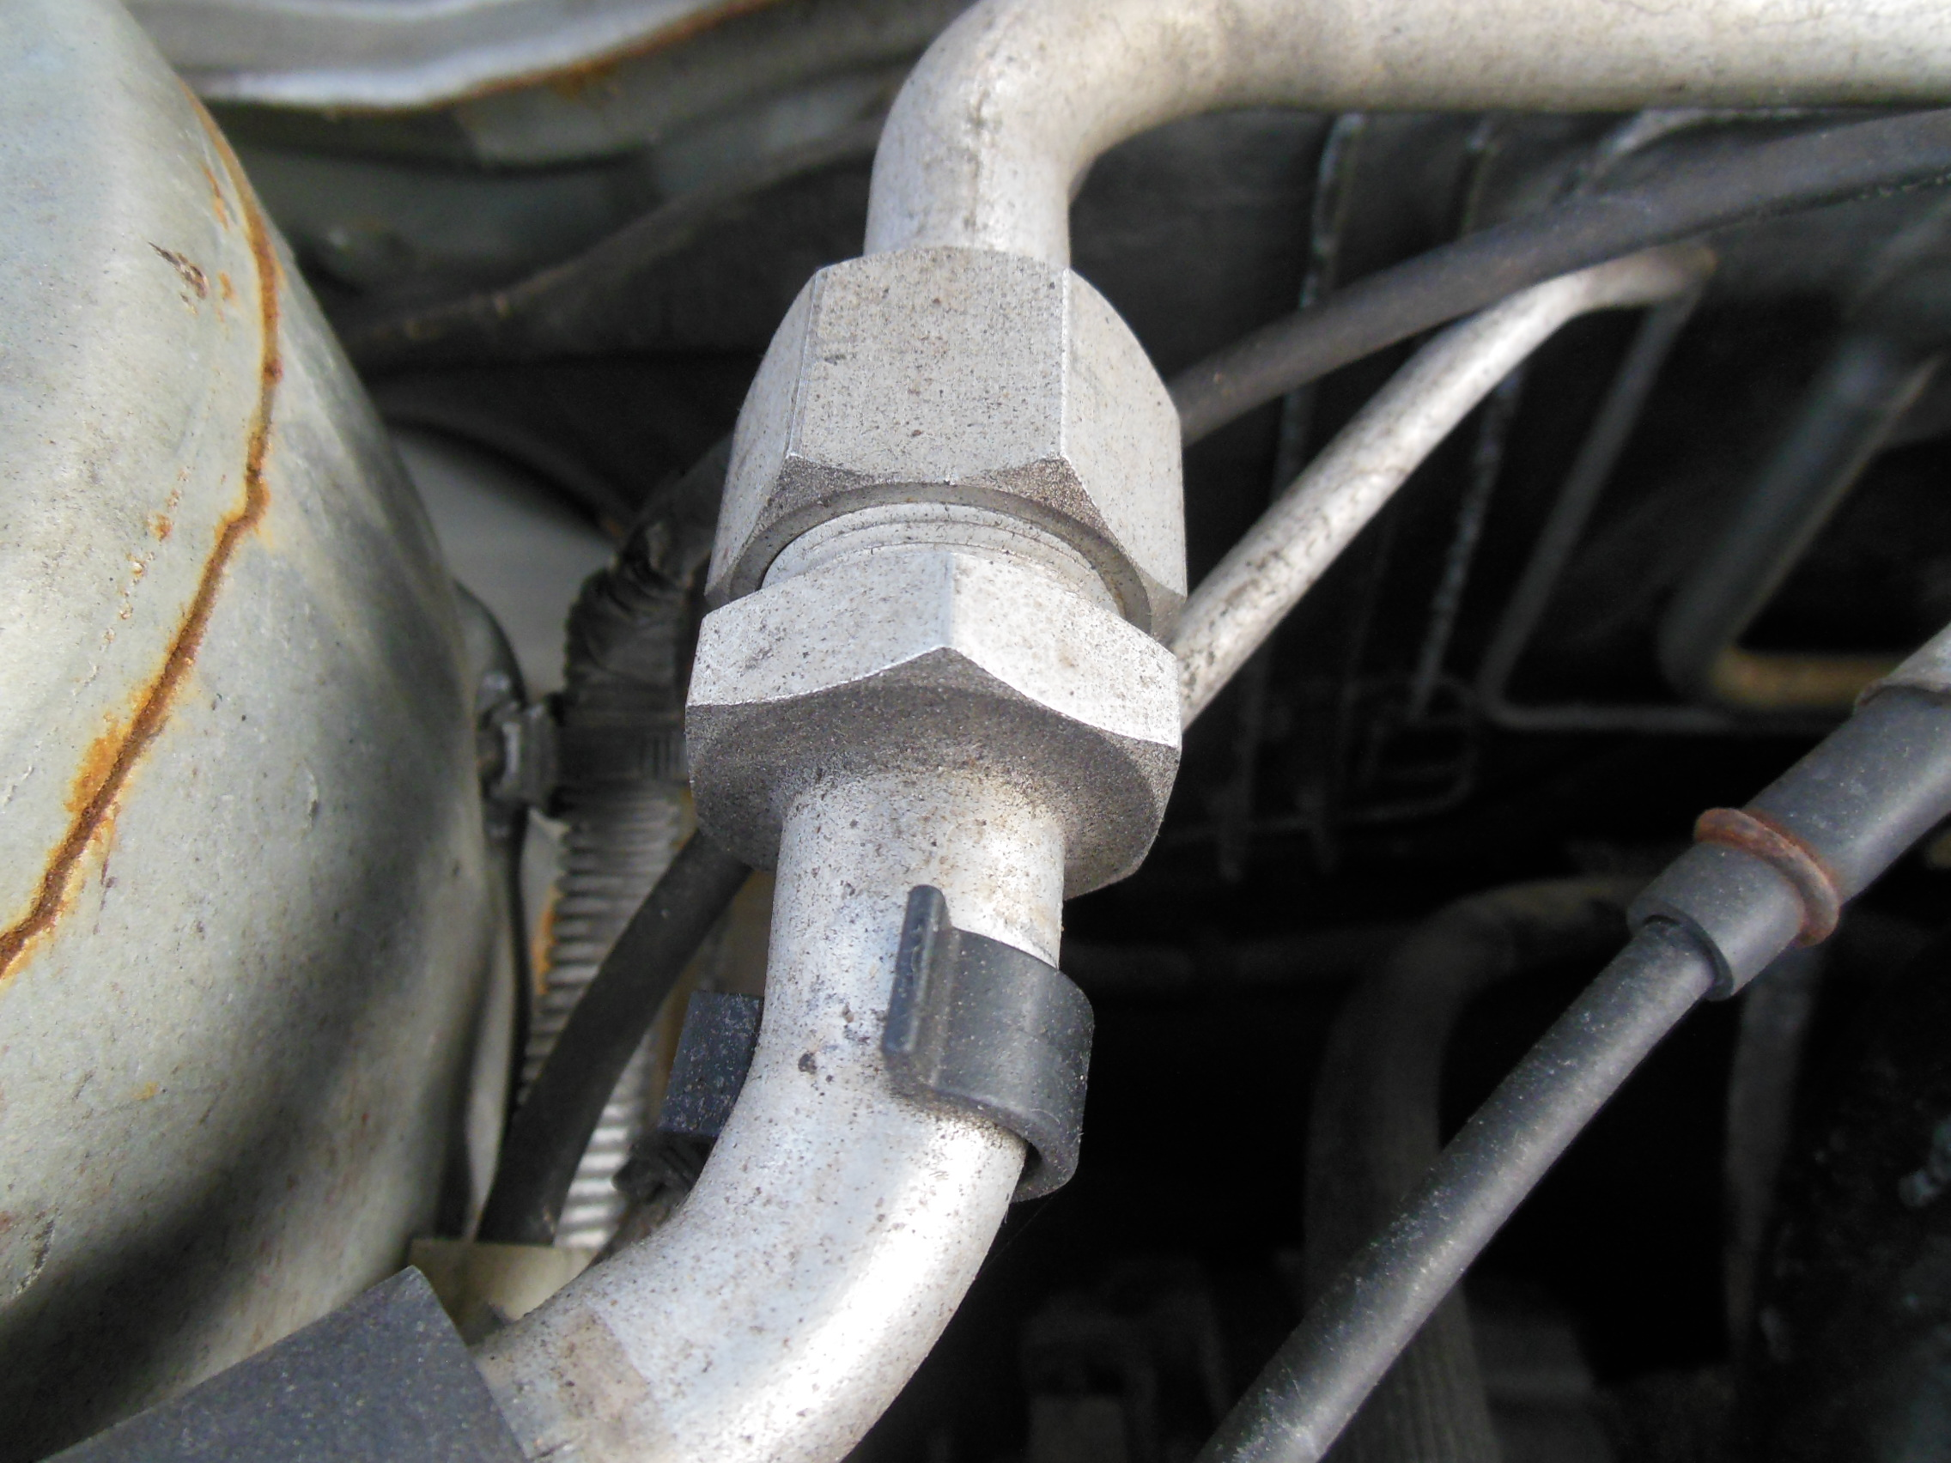

_____ 2. Based on the inspection, what is the needed action? ___________________________
_________________________________________________________________
_________________________________________________________________
_________________________________________________________________

