Receiver/Drier Accumulator Drier
Meets ASE Task: (A7-B-8) P-2 Remove, inspect, and reinstall drier assembly; determine required oil quantity.

Name _______________________________ Date ___________ Time on Task __________

Make/Model/Year _________________ VIN ________________ Evaluation: 4 3 2 1

_____ 1. Check service information for the procedure and tools needed to remove the drier
assembly. ____________________________________________________________
__________________________________________________________________ __________________________________________________________________
__________________________________________________________________
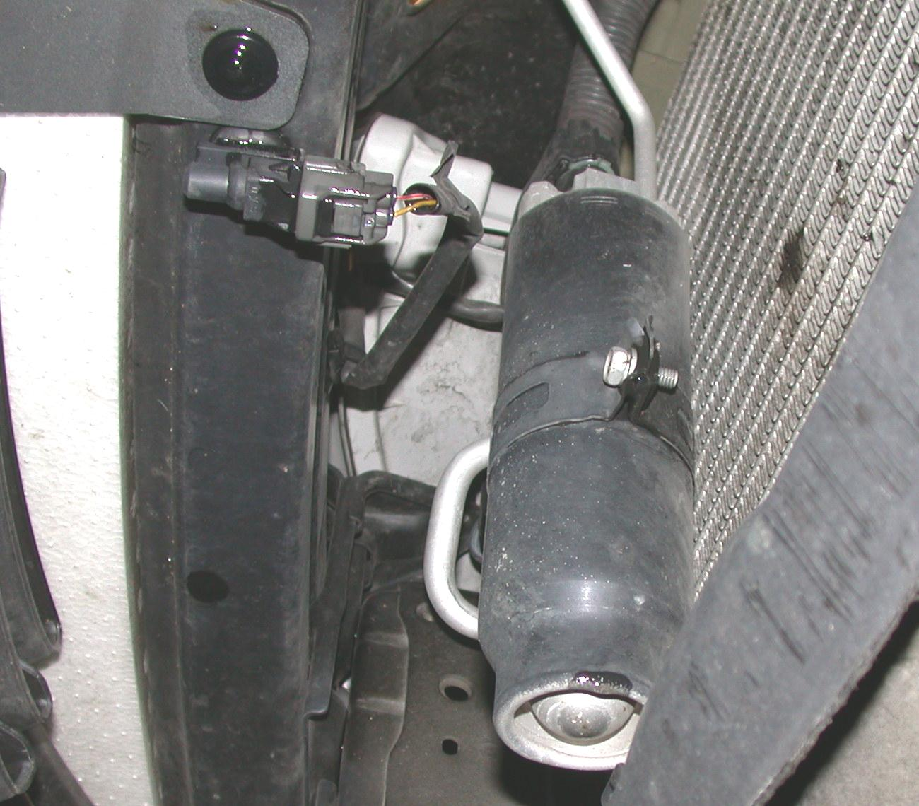

_____ 2. Check service information and determine the required amount of oil needed to be
added to the system if the drier assembly is replaced. ___________________ oz.
_____ 3. What was the condition of the removed drier assembly? ________________________
__________________________________________________________________
__________________________________________________________________

