Inspect the Air Conditioning Condenser
Meets ASE Task: (A7-B-7) P-1 Inspect A/C condenser for airflow restriction; perform needed action.

Name _______________________________ Date ___________ Time on Task __________

Make/Model/Year _________________ VIN ________________ Evaluation: 4 3 2 1

_____ 1. Check service information on how to gain access to the front side of the condenser
(describe what needs to be done). __________________________________________
___________________________________________________________________
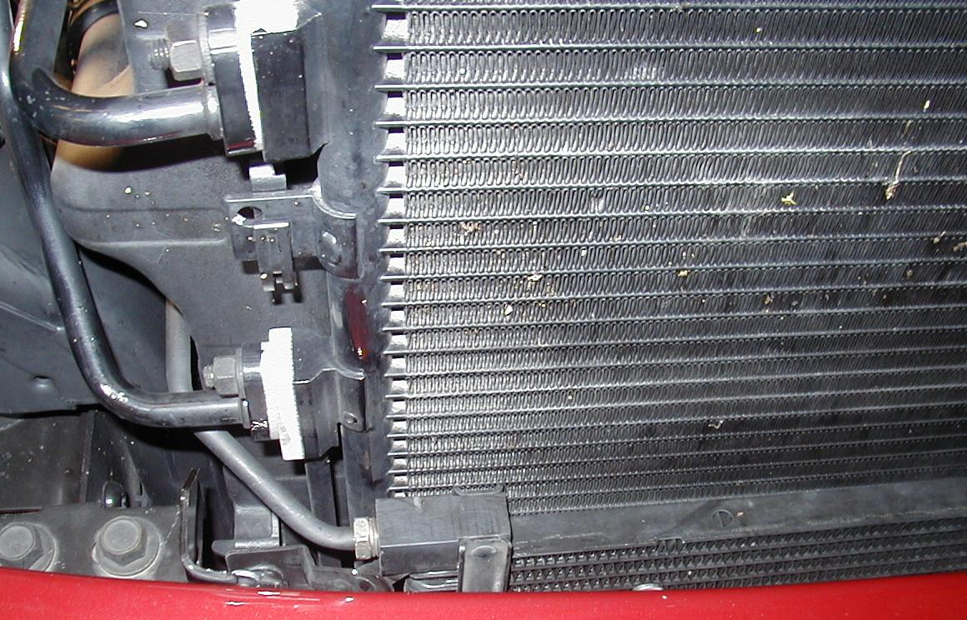
___________________________________________________________________

_____ 2. What is the recommended method and/or tools needed to clean the condenser?
___________________________________________________________________
___________________________________________________________________
___________________________________________________________________
_____ 3. Based on the inspection, what is the needed action? ____________________________
___________________________________________________________________
___________________________________________________________________

