HVAC Diagnosis
Meets ASE Task: (A7-A-9) P-3, (A7-B-11) P-2 Using a scan tool, record the HVAC-related data/DTCs; diagnose A/C system conditions.

Name _______________________________ Date ___________ Time on Task __________

Make/Model/Year _________________ VIN ________________ Evaluation: 4 3 2 1

_____ 1. Check service information to check how to access data and diagnostic trouble codes.
__________________________________________________________________
__________________________________________________________________
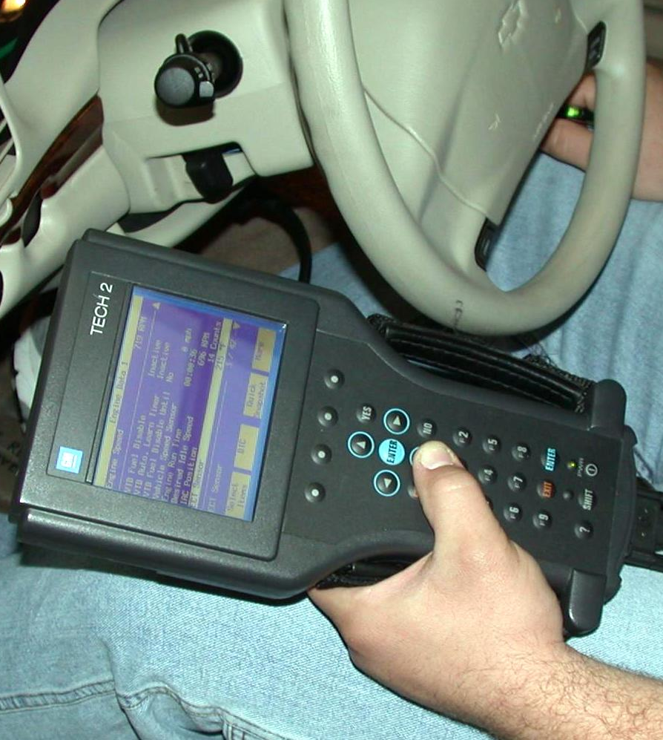

_____ 2. What if any diagnostic trouble codes were displayed? _________________________

_____ 3. Check service information and determine what protective devices are used on the
vehicle being serviced. Check all that apply.
____ a. Low-pressure switch (describe location) __________________________
____ b. High-pressure switch (describe location) __________________________
____ c. Thermal protective device (describe location) ______________________
____ d. Other (describe) _____________________________________________
____ e. Odors? (describe) ___________________________________________
____ f. Cables and control panel operation ______________________________

