Module Communication

Meets ASE Task: (A6-A-12) P-1 Check for module communication errors using a scan tool.

Name _______________________________ Date ___________ Time on Task __________

Make/Model/Year _________________ VIN ________________ Evaluation: 4 3 2 1

_____ 1. Check service information for the specified method and procedures to follow to check
for proper module communications.
_________________________________________________________________
_________________________________________________________________
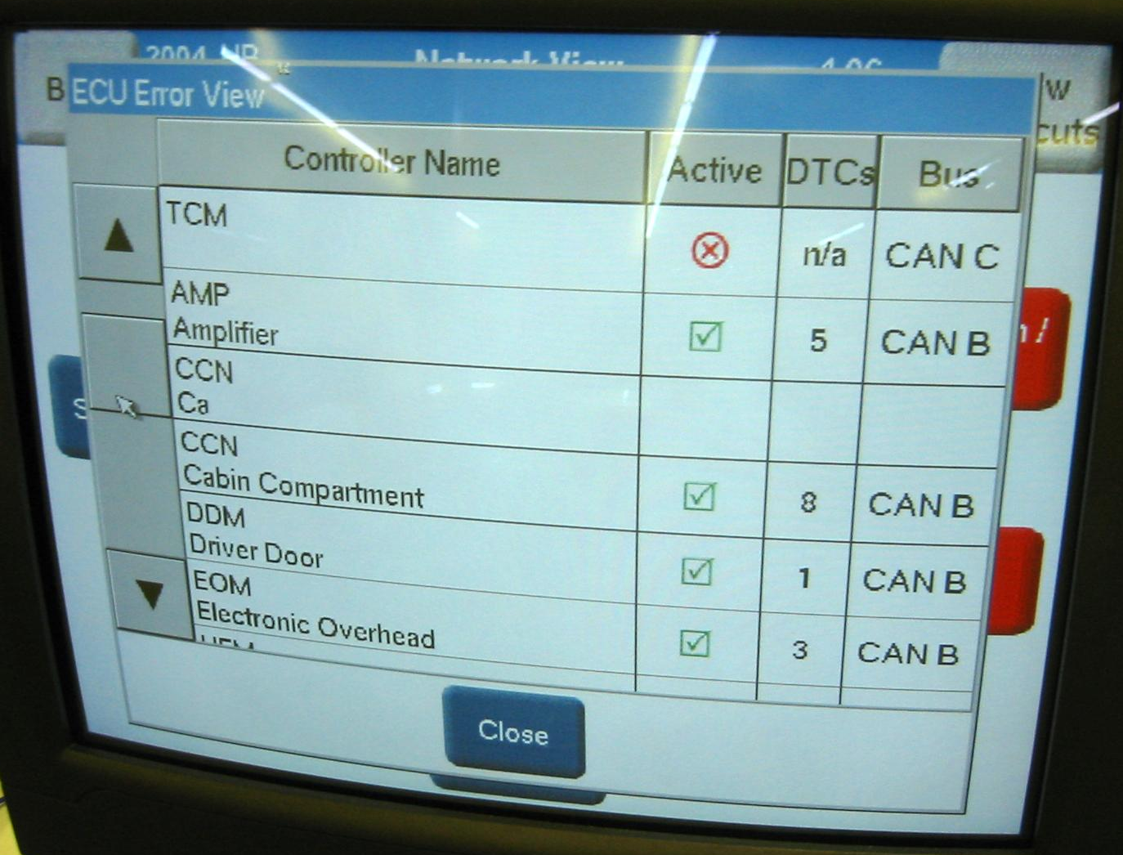
_____ 2. Check all that apply:

___ Use a factory scan tool.

___ Use a global OBD-II scan tool.

___ Use a DMM to check for resistance
on communication circuits.

___ Use a fused jumper wire and a scan
tool to diagnose communication
errors.

___ Other (describe) ________________________________________________

_____ 3. List the modules that are preset in the vehicle being tested.

a. _________________________ f. _________________________
b. _________________________ g. _________________________
c. _________________________ h. _________________________
d. _________________________ j. _________________________
e. _________________________ k. _________________________

_____ 4. Based on the test results, what is the needed action? _______________________

________________________________________________________________

