Brake System Road Test
Meets ASE Task: (A5-A-3) P-1 Describe the procedure for performing a road test to check brake system operation.

Name _______________________________ Date ___________ Time on Task __________

Make/Model/Year _________________ VIN ________________ Evaluation: 4 3 2 1

_____ 1. Check service information for the specified procedure to follow when performing a
test drive to check for a brake system fault. Describe the specified procedure.
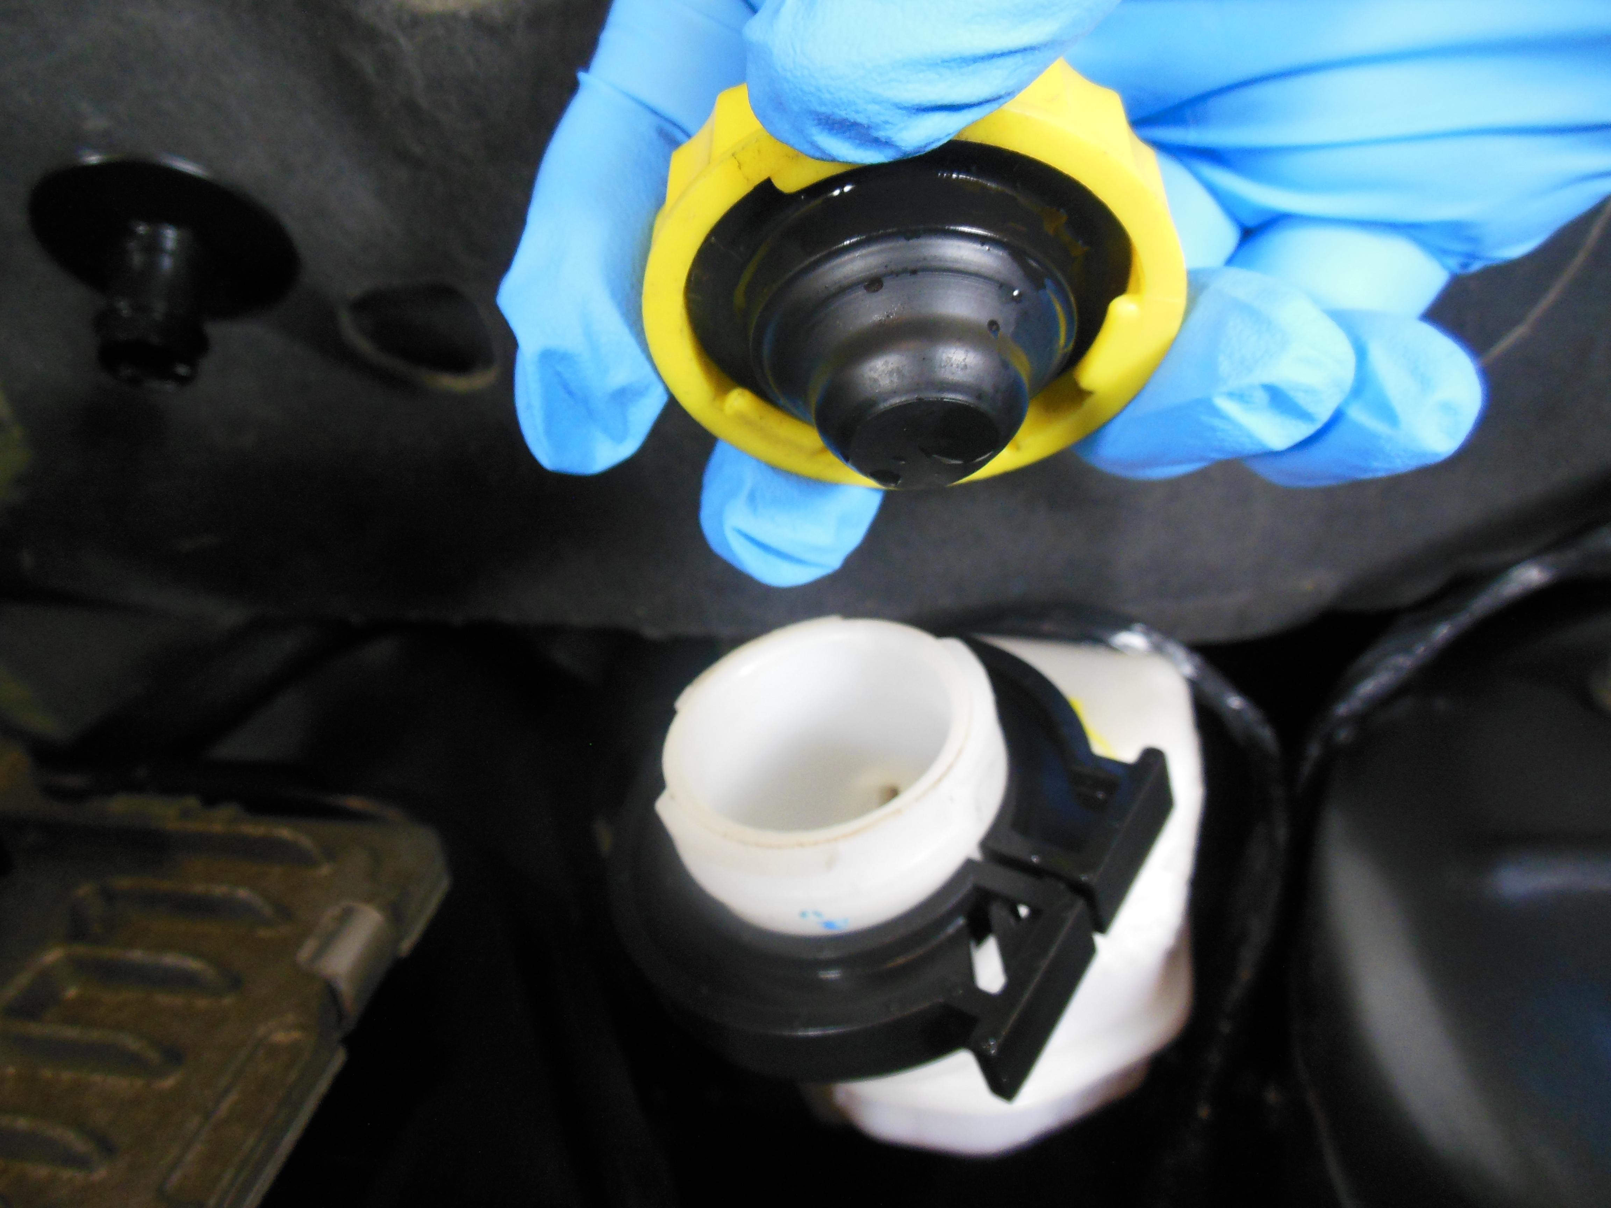
________________________
________________________
________________________
________________________
________________________

_____2. Check all that are specified.
___ Check the brake fluid level before driving
___ Check the brake pedal height
___ Perform a visual inspection of wheels/tires
___ Other (Specify) _________________________________________________
____________________________________________________________
CAUTION: Most experts state that the vehicle should not be road tested if the red brake
warning light is on. Always follow the vehicle manufacturer’s recommended

procedures.

