ABS Wheel Speed Sensor Testing

Meets ASE Task: (A5-G-7) P-2 Test, diagnose, and service ABS wheel speed sensors.

Name _______________________________ Date ___________ Time on Task __________

Make/Model/Year _________________ VIN ________________ Evaluation: 4 3 2 1

A magnetic wheel speed sensor can fail in a variety of ways including: electrically shorted, open, or grounded.

_____ 1. Locate and disconnect the wheel speed sensor connector. Hoist the vehicle if
needed.

_____ 2. Disconnect the wheel speed sensor (WSS) connector and connect a digital meter set to
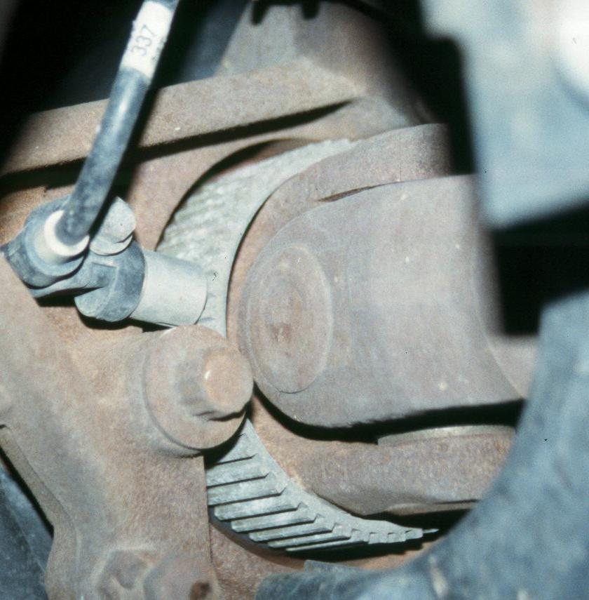
read ohms.

_____ 3. Measure the resistance at the sensor terminals.

WSS resistance = ________

Compare the resistance to the factory
specifications = __________
(usually about 1000 ohms).
OK _____ NOT OK _____

_____ 4. With the meter still set to read ohms, connect one meter lead to a good clean chassis
ground and the other lead to one terminal of the WSS connector. This test determines
that the WSS is shorted to ground unless the meter indicates infinity (OL).

Meter reading = _____ should be infinity (OL). OK _____ NOT OK _____

_____ 5. Set the digital meter to read AC volts.

_____ 6. Connect the leads of the meter to the terminals of the wheel speed sensor.

_____ 7. Have an assistant spin the wheel and observe the AC voltage on the meter display.

Reading = ________ AC volts (should be over 0.1 V (100 mV)

OK _____ NOT OK _____

_____ 8. Observe the wheel speed sensor using a graphing multimeter (GMM) or a digital
storage oscilloscope (DSO). Draw the waveform displayed while an assistant spins
the wheel.

