Dual-Mass Flywheel
Meets ASE Task: (A3-B-8) P-3 Describe the operation and service of a clutch system that uses a dual-mass flywheel.

Name _______________________________ Date ___________ Time on Task __________

Make/Model/Year _________________ VIN ________________ Evaluation: 4 3 2 1

_____ 1. Check service information and check for the specified service procedures that may be
needed to be performed on a vehicle equipped with a dual-mass flywheel.
__________________________________________________________________
__________________________________________________________________
__________________________________________________________________
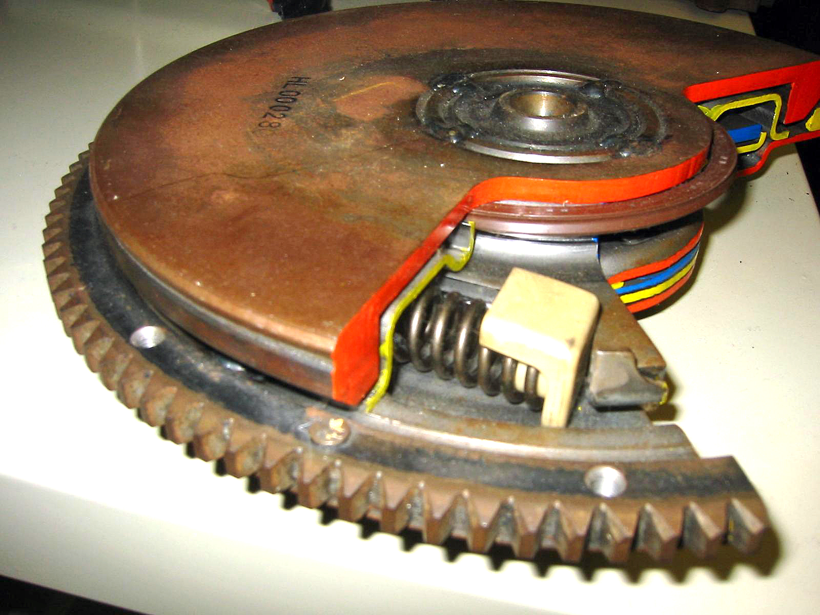

_____ 2. Describe why a dual-mass flywheel is used in some vehicles. ___________________
_________________________________________________________________
_________________________________________________________________

