Transaxle Final Drive Inspection

Meets ASE Task: (A2-C-18) P-2 Inspect, repair, or replace transaxle final drive components.

Name _______________________________ Date ___________ Time on Task __________

Make/Model/Year _________________ VIN ________________ Evaluation: 4 3 2 1

_____ 1. Check service information and determine the specified procedures to follow when
inspecting the final drive assembly of an automatic transaxle. Describe the specified
procedures. _____________________________________________________________
____________________________________________________________________
____________________________________________________________________
____________________________________________________________________
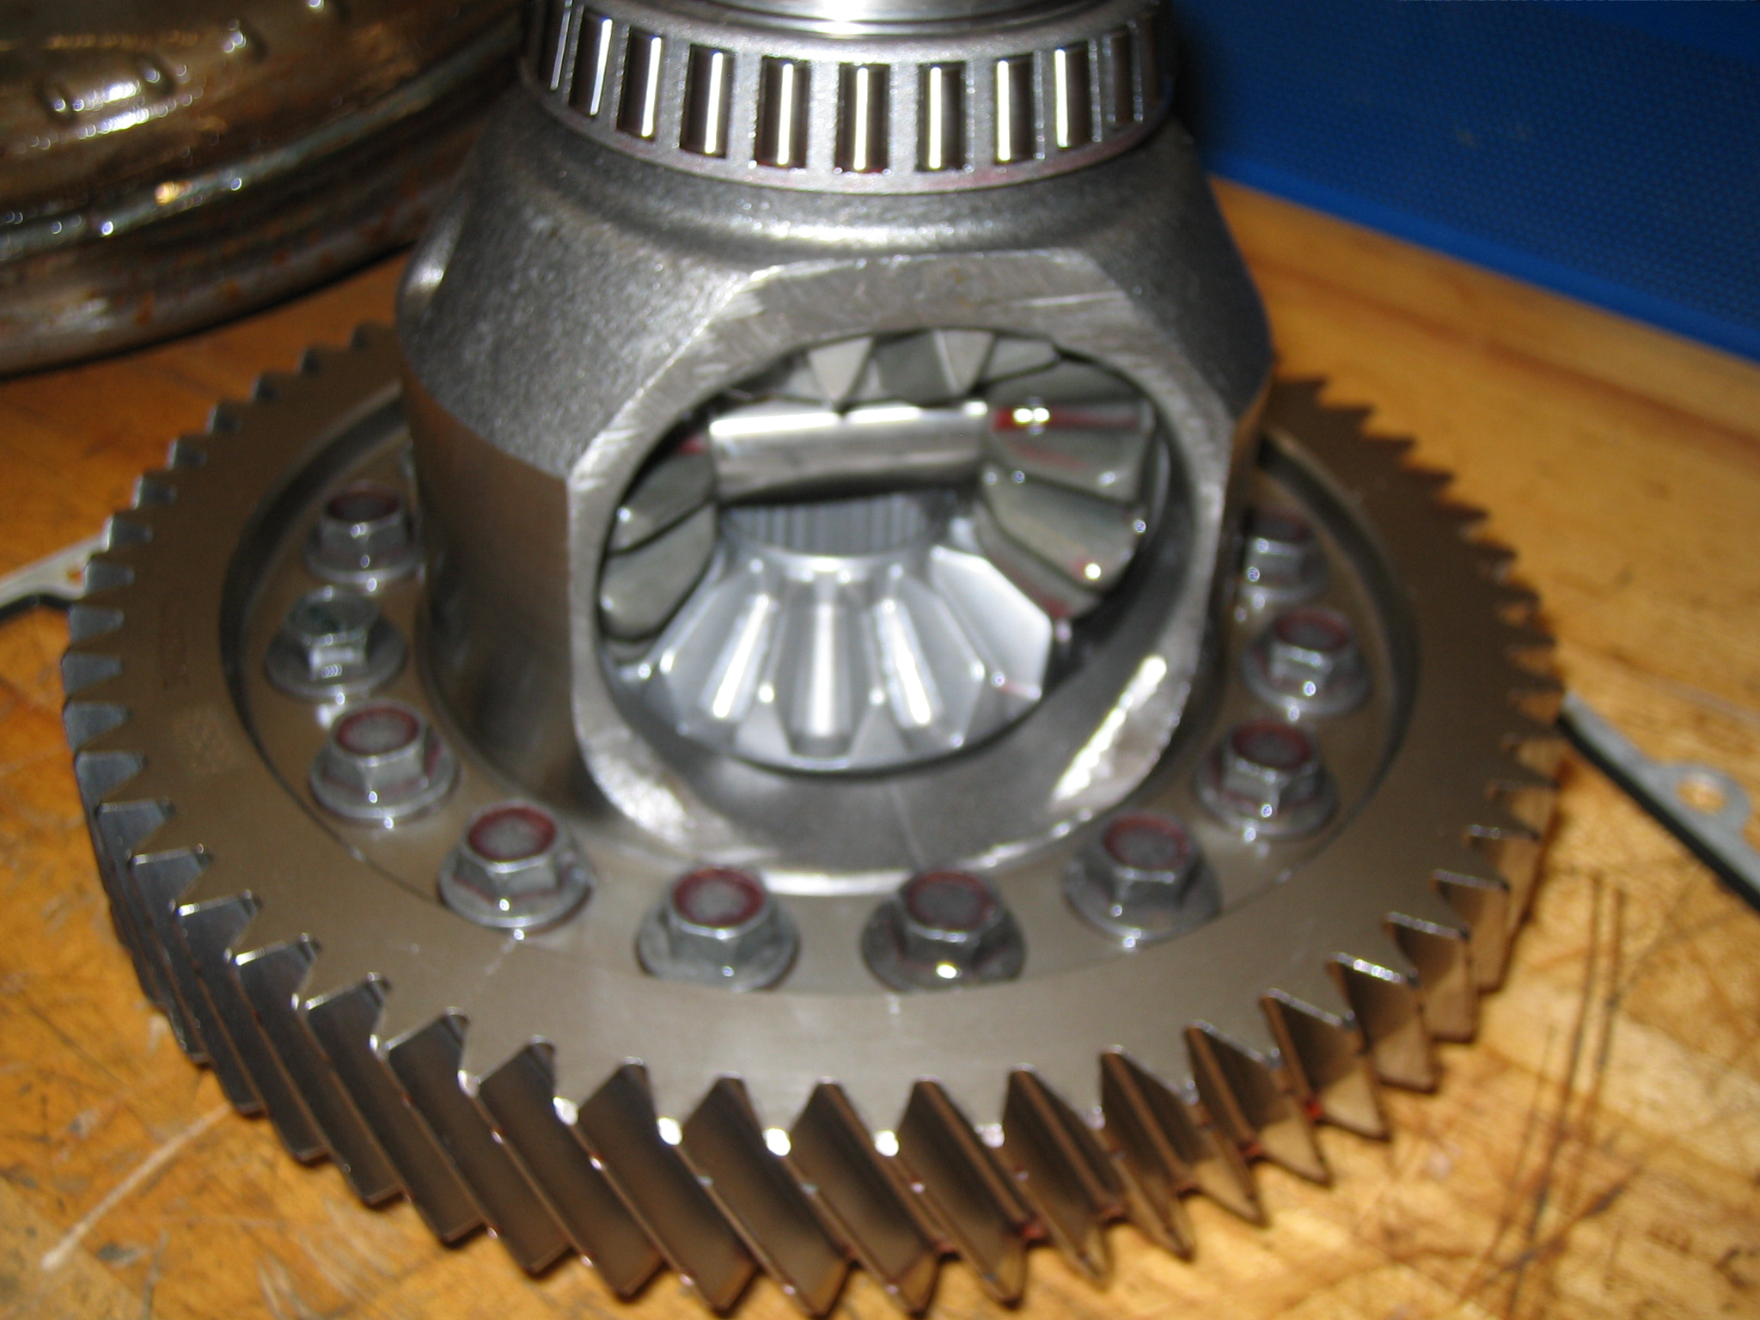

_____ 2. Based on the inspection results and the recommendations of service information, what is
the needed action? _______________________________________________________
____________________________________________________________________
____________________________________________________________________

