Inspect Oil Pump Assembly

Meets ASE Task: (A2-C-10) P-2 Inspect oil pump assembly.

Name _______________________________ Date ___________ Time on Task __________

Make/Model/Year _________________ VIN ________________ Evaluation: 4 3 2 1

_____ 1. Check service information for the specified procedure to follow when inspecting the oil
pump assembly. Describe the inspection procedures. ____________________________
____________________________________________________________________
____________________________________________________________________
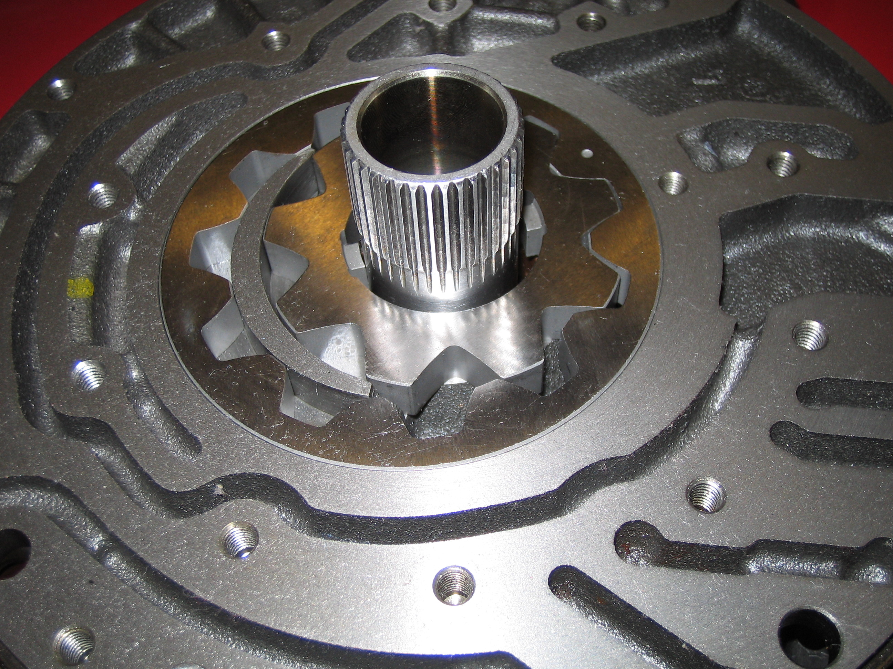
____________________________________________________________________

_____ 2. According to the results of the inspection, should the oil pump assembly be replaced?
No ____ Yes ____ If yes, explain the reason. ____________________________
___________________________________________________________________
___________________________________________________________________
___________________________________________________________________

