Electronic Transmission Scan Tool Diagnosis
Meets ASE Task: (A2-A-11) P-1 Diagnose electronic transmission control system using a scan tool.

Name _______________________________ Date ___________ Time on Task __________

Make/Model/Year _________________ VIN ________________ Evaluation: 4 3 2 1

_____ 1. Check service information for the exact procedures and equipment needed to identify
and diagnose electronic transmission control systems using a scan tool (describe). _____
____________________________________________________________________
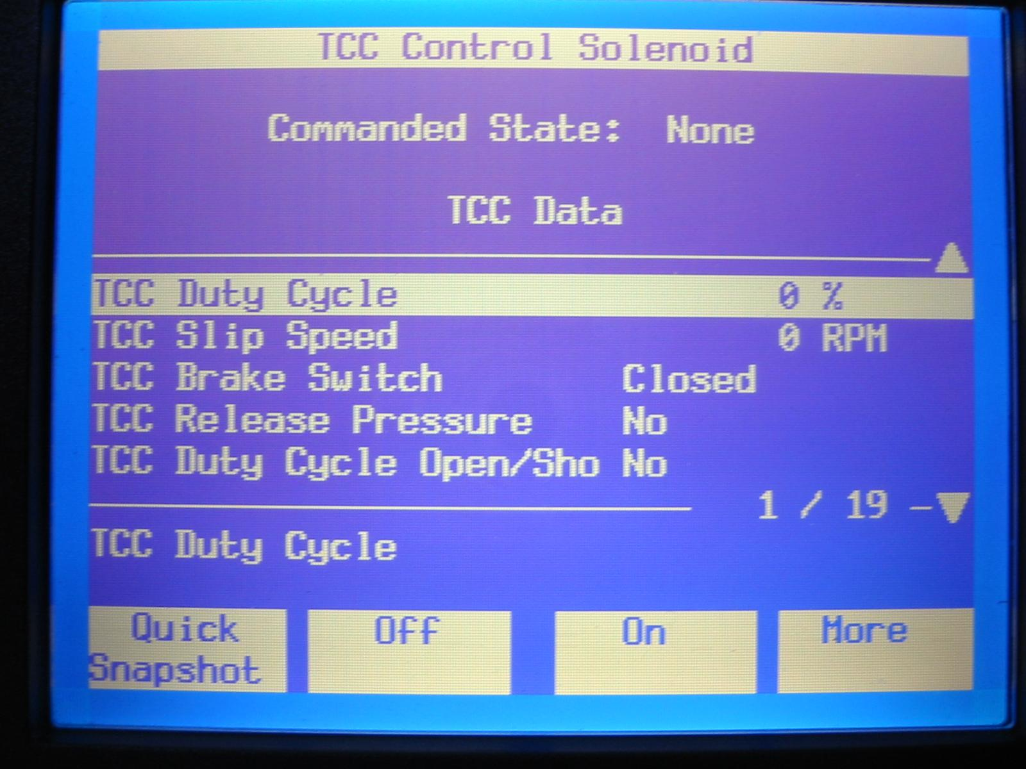
____________________________________________________________________

_____ 2. What is the designated scan
tool to be used? _____________
___________________________
___________________________
___________________________
___________________________
_____ 3. What was the result of the scan
tool diagnosis? ______________
___________________________
_______________________________________________________________________
_______________________________________________________________________
_____ 4. List all transmission-related diagnostic trouble codes.
Code (DTC) Meaning of DTC
a. ____________________________ ________________________________
b. ____________________________ ________________________________
c. ____________________________ ________________________________
d. ____________________________ ________________________________

