Assemble Automatic Transmission/Transaxle

Meets ASE Task: (A2-C-9) P-1 Assemble automatic transmission/transaxle.

Name _______________________________ Date ___________ Time on Task __________

Make/Model/Year _________________ VIN ________________ Evaluation: 4 3 2 1

_____ 1. Check service information for the recommended procedures for assembling the specific
automatic transmission/transaxle being service. Summarize the specified procedures.
____________________________________________________________________
____________________________________________________________________
____________________________________________________________________
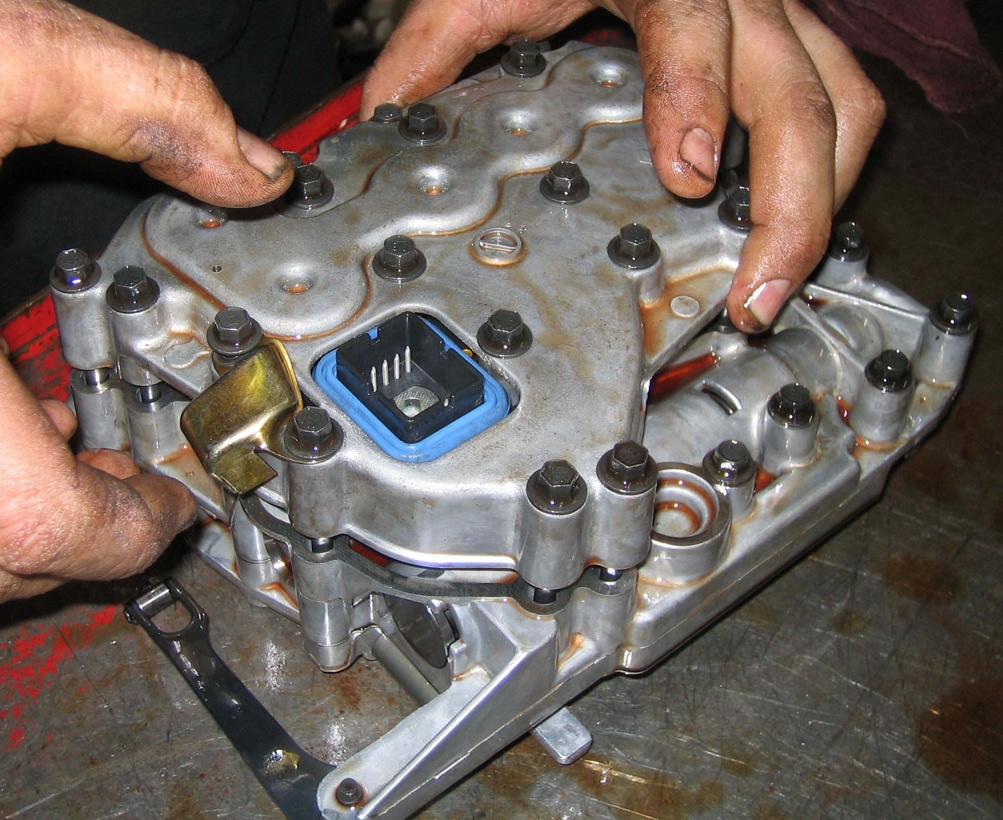
____________________________________________________________________

_____ 2. List the torque specifications of all fasteners.
Fastener (description) Specified Torque
_______________________________ _________________________
_______________________________ _________________________
_______________________________ _________________________
_______________________________ _________________________
_______________________________ _________________________

