Crankshaft Vibration Damper
Meets ASE Task: (A1-C-1) P-1 Remove, inspect or replace crankshaft vibration damper (harmonic balancer).

Name _______________________________ Date ___________ Time on Task __________

Make/Model/Year _________________ VIN ________________ Evaluation: 4 3 2 1

_____ 1. Check service information for the specified inspection and installation procedure.
__________________________________________________________________
__________________________________________________________________
__________________________________________________________________
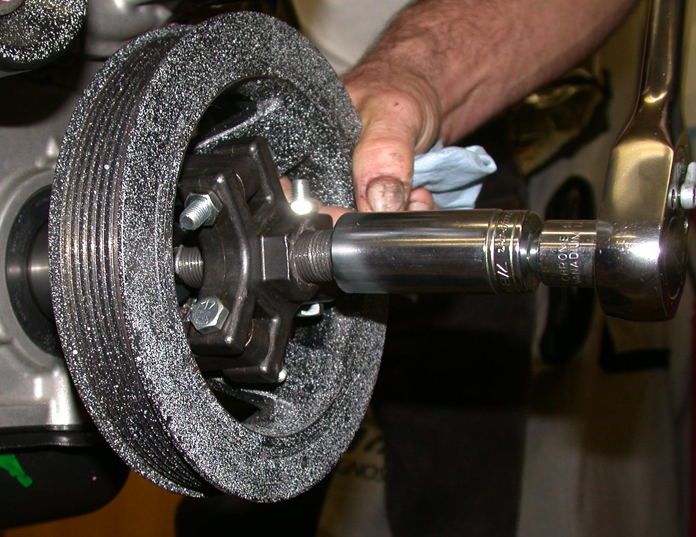
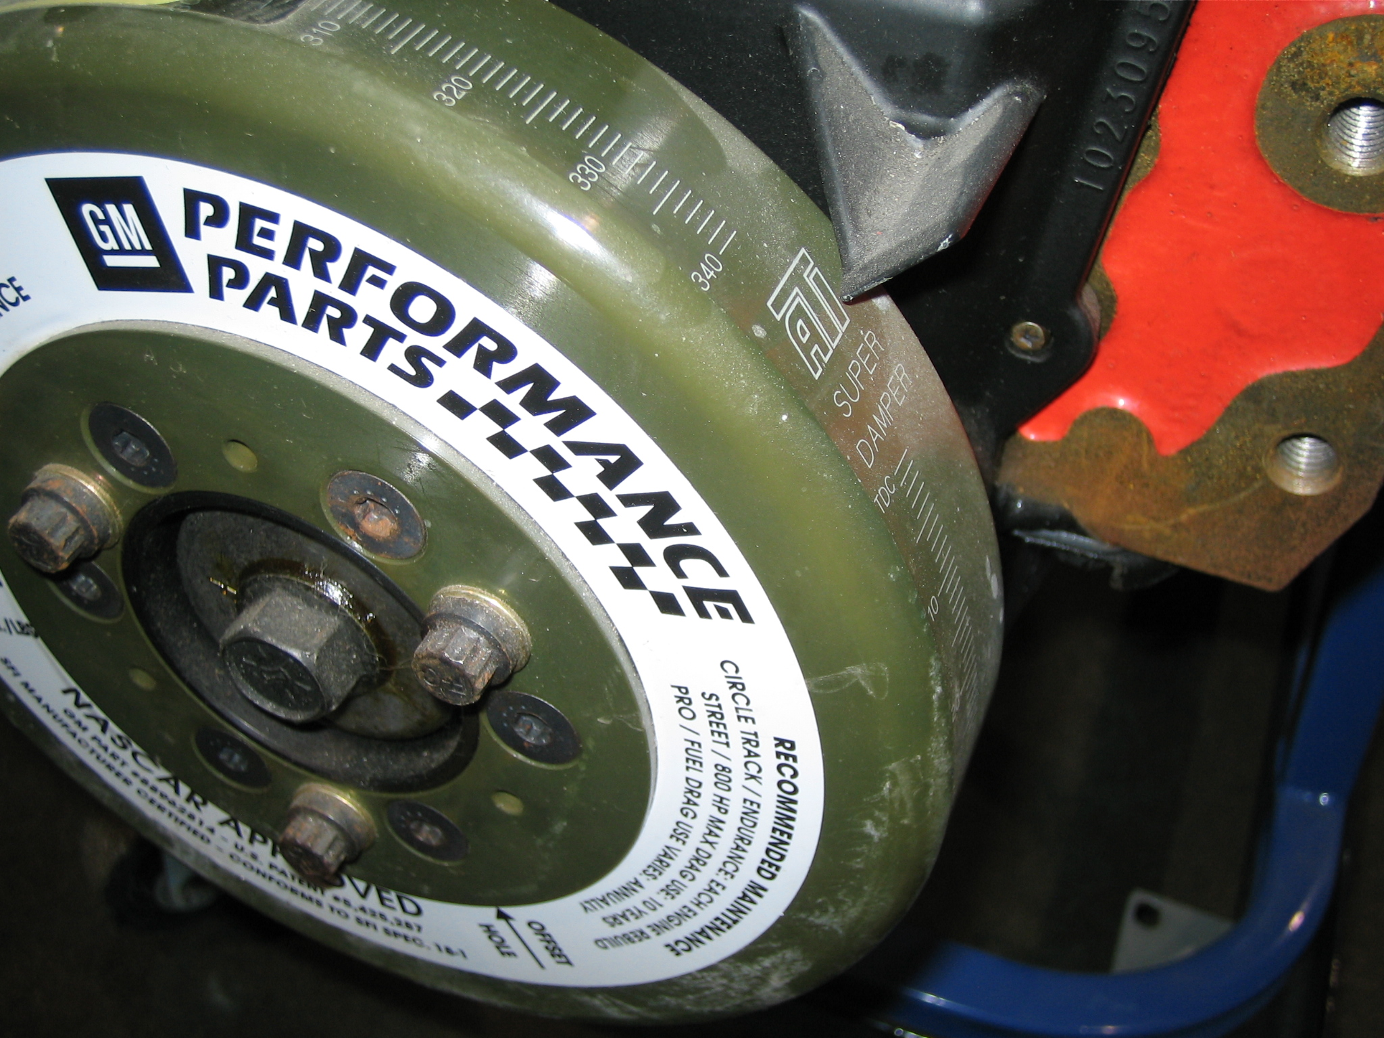
_____ 2. Visually check the condition of the crankshaft vibration damper (harmonic balancer)
including:
a. Rubber connection between the inner and outer rings
b. Nose area for wear from the front seal
OK ____ NOT OK ____ Describe faults: _____________________________
_________________________________________________________________
_____ 3. Check service information for the specified torque specifications for the crankshaft
vibration damper retaining bolt. Torque specification = ________________
_____ 4. Install the crankshaft vibration damper and tighten the retaining bolt to factory
specifications.

