1. Check service information and determine the testing and diagnostic procedures to
Evaluation (Enter number from 4, 3, 2, 1) :_________

Meets ASE Task: A7 – D-4 – P-1
Time on Task:_____________
Make/Model/Year:____________________________________
VIN:_________________________________
Date:_____________
Name:_____________________________________
A/C Compressor Control System Diagnosis
follow when diagnosing faults in the A/C compressor clutch control system (describe
tests).
______________________________________________________________________________
______________________________________________________________________________
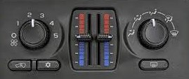

2. What test equipment is specified for use during the diagnosis? Check all that apply.
______ a. DMM
______ b. Scope
______ c. Scan tool
______ d. Special tester (describe) __________________________________________
______ e. Other (describe) ________________________________________________
3. After testing the A/C compressor control system, what is the necessary action? ______________________________________________________________________________
______________________________________________________________________________

