1. Check service information and list the inspection and replacement procedures for the
Evaluation (Enter number from 4, 3, 2, 1) :_________

Meets ASE Task: A7 – B-5 – P-1
Time on Task:_____________
Make/Model/Year:____________________________________
VIN:_________________________________
Date:_____________
Name:_____________________________________
Air Conditioning Compressor Service
A/C compressor drive belt clutch and replacement.
____________________________________________________________________________
____________________________________________________________________________
2. What is the specified method to use to determine the quantity of refrigerant oil?
____________________________________________________________________________
____________________________________________________________________________
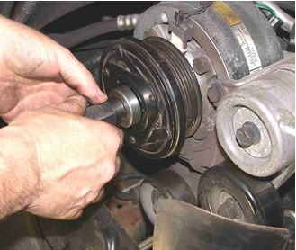

3. Inspect lines and fittings (describe)
____________________________________________________________________________
4. Based on the inspection, what is the necessary action?
_____________________________________________________________________________
_____________________________________________________________________________

