1. Check service information and determine the testing and diagnostic procedures to
Evaluation (Enter number from 4, 3, 2, 1) :_________

Meets ASE Task: A7 – B-4 – P-2
Time on Task:_____________
Make/Model/Year:____________________________________
VIN:_________________________________
Date:_____________
Name:_____________________________________
A/C Compressor Clutch Control Diagnosis
follow when diagnosing faults in the A/C compressor clutch control circuit (describe
tests).
__________________________________________________________________________
__________________________________________________________________________
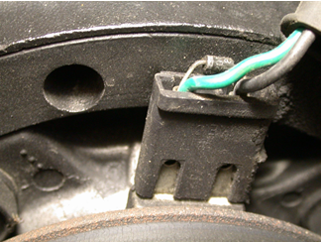
2. What test equipment is specified for use during the diagnosis? Check all that apply.
______ a. DMM
______ b. Scope
______ c. Scan tool
______ d. Special tester (describe) _____________________________________
______ e. Other (describe) ___________________________________________

3. After testing the A/C compressor clutch circuit, what is the necessary action?
__________________________________________________________________________
__________________________________________________________________________

