1. Check the vehicle for odors that are noticeable when the A/C system is operating.
Evaluation (Enter number from 4, 3, 2, 1) :_________

Meets ASE Task: A7 – D-2 – P-2
Time on Task:_____________
Make/Model/Year:____________________________________
VIN:_________________________________
Date:_____________
Name:_____________________________________
Identify Source of A/C Odors
Describe the odor. ______________________________________________________________
______________________________________________________________________________
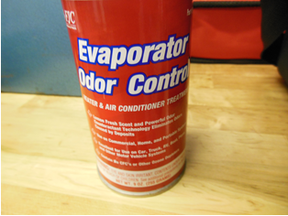

2. Check service information for the specified procedure to follow to eliminate the
source of the odor. Describe the specified procedure. _________________________________
______________________________________________________________________________
