1. Check service information to determine the procedure for removing and replacing the evaporator. ___________________________________________________________________
Evaluation (Enter number from 4, 3, 2, 1) :_________

Meets ASE Task: A7 – B-10 – P-2
Time on Task:_____________
Make/Model/Year:____________________________________
VIN:_________________________________
Date:_____________
Name:_____________________________________
Remove and Install Evaporator
______________________________________________________________________________
______________________________________________________________________________

2. Check service information and determine what special tools are needed. __________________
_____________________________________________________________________________
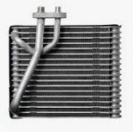

3. Remove and replace the evaporator.

4. Evacuate and recharge the air conditioning system. Check the system for leaks and proper cooling.

