1. Check service information to determine what the customer concern would be if the
Evaluation (Enter number from 4, 3, 2, 1) :_________

Meets ASE Task: A7 – B-3 – P-1
Time on Task:_____________
Make/Model/Year:____________________________________
VIN:_________________________________
Date:_____________
Name:_____________________________________
Evaporator Housing Drain
evaporator drain was clogged. ___________________________________________________
_____________________________________________________________________________

2. Check service information and determine the location of the evaporator drain (describe
the location). __________________________________________________________________
_____________________________________________________________________________
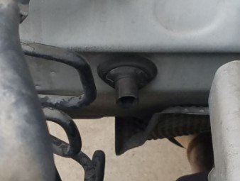
3. Inspect the drain. Was it clogged? Yes _______ No _______

4. Based on the inspection, what is the necessary action?
______________________________________________________________________________
______________________________________________________________________________

