1. What brand and type of refrigerant handling equipment is being used (describe)?
Evaluation (Enter number from 4, 3, 2, 1) :_________

Meets ASE Task: A7 – E-2 – P-1
Time on Task:_____________
Make/Model/Year:____________________________________
VIN:_________________________________
Date:_____________
Name:_____________________________________
Refrigerant Handling Equipment
_____________________________________________________________________________
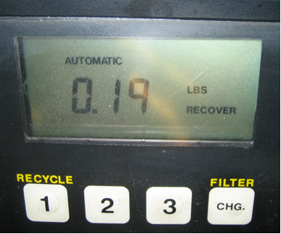

2. Check the instructions for the equipment and list the maintenance items that should be
performed.
_____________________________________________________________________________
_____________________________________________________________________________
3. Check the instructions and describe how to properly use the refrigerant handling
equipment.
_____________________________________________________________________________
_____________________________________________________________________________

