1. Check service information on how to gain access to the front side of the condenser (describe what needs to be done). _________________________________________________
Evaluation (Enter number from 4, 3, 2, 1) :_________

Meets ASE Task: A7 – B-2 – P-1
Time on Task:_____________
Make/Model/Year:____________________________________
VIN:_________________________________
Date:_____________
Name:_____________________________________
Inspect the AC Condenser for Proper Airflow
_____________________________________________________________________________
_____________________________________________________________________________
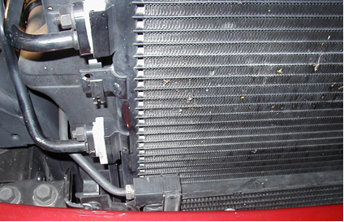
2. What is the recommended method and/or tools needed to test the air flow across the condenser and to clean the surface? ________________________________________________
______________________________________________________________________________
______________________________________________________________________________
3. Based on the inspection, what is the necessary action? _________________________________
______________________________________________________________________________
______________________________________________________________________________

