1. Describe the purpose and function of the A/C compressor.

Evaluation (Enter number from 4, 3, 2, 1) :_________

Meets ASE Task: A7 – A-2 – P-1

Time on Task:_____________

Make/Model/Year:____________________________________

VIN:_________________________________

Date:_____________

Name:_____________________________________

**A/C Component Purpose and Function**

______________________________________________________________________________

______________________________________________________________________________

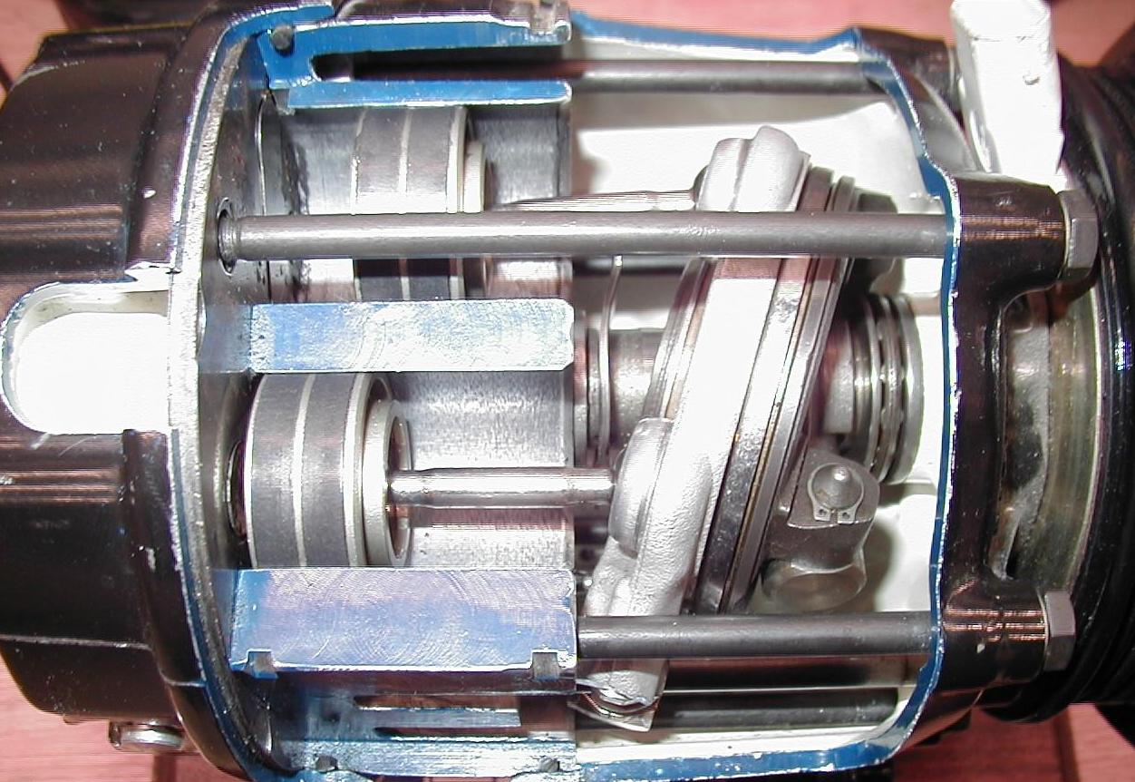

2. Describe the purpose and function of the condenser.

______________________________________________________________________________

3. Describe the purpose and function of the thermal expansion valve (TXV).

______________________________________________________________________________

4. Describe the purpose and function of the orifice tube (OT).

______________________________________________________________________________

5. Describe the purpose and function of the evaporator.

______________________________________________________________________________

6. Describe the purpose and function of the accumulator or receiver-drier.

______________________________________________________________________________