1. Check service information and describe the leak detection recommended by the vehicle manufacturer. __________________________________________________________________
Evaluation (Enter number from 4, 3, 2, 1) :_________

Meets ASE Task: A7 – D-2 – P-2
Time on Task:_____________
Make/Model/Year:____________________________________
VIN:_________________________________
Date:_____________
Name:_____________________________________
Leak Test the Air Conditioning System
______________________________________________________________________________

2. What type(s) of leak detection tools or equipment was used (describe)? ___________________
______________________________________________________________________________
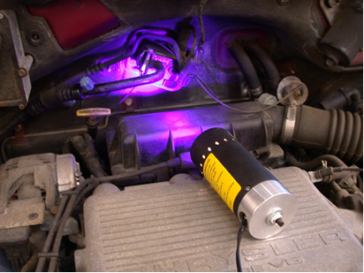
3. Was a leak detected? Yes _____ No _____ if yes, describe the location. ________________
_____________________________________________________________________________

4. Based on the test results, what is the necessary action? ________________________________
______________________________________________________________________________
______________________________________________________________________________

