1. Check service information and describe the tests specified to diagnosis faults in the

Evaluation (Enter number from 4, 3, 2, 1) :_________

Meets ASE Task: A7 – D-5 – P-2

Time on Task:_____________

Make/Model/Year:____________________________________

VIN:_________________________________

Date:_____________

Name:_____________________________________

**Air Conditioning Control System Diagnosis**

vacuum, mechanical, and electrical controls of the heating, ventilation, and air

conditioning system (describe the tests). ____________________________________________

______________________________________________________________________________

______________________________________________________________________________

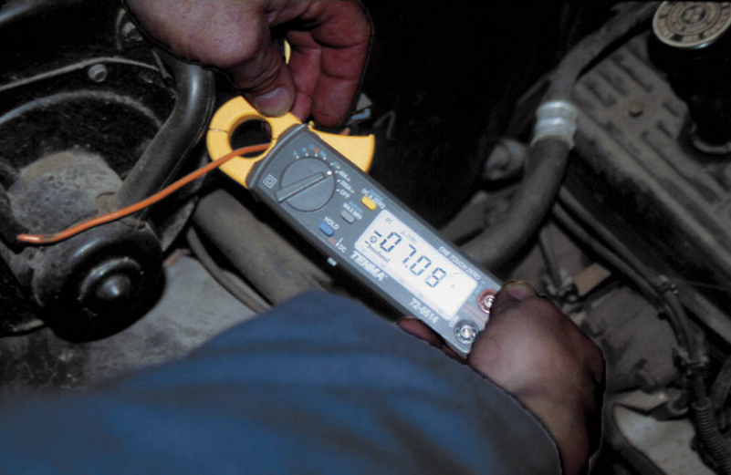

2. What test equipment was specified to be used in the diagnosis of faults in the vacuum,

mechanical, and electrical HVAC system? Check all that apply.

______a. Hand-operated vacuum pump

______ b. DMM

______c. Scan tool

______d. Other (describe) ___________________________________________

3. After diagnosing the HVAC system, what is the necessary action? _________________________

______________________________________________________________________________