1. Check service information and determine the specified procedures to follow to replace
Evaluation (Enter number from 4, 3, 2, 1) :_________

Meets ASE Task: A7 – C-4 – P-2
Time on Task:_____________
Make/Model/Year:____________________________________
VIN:_________________________________
Date:_____________
Name:_____________________________________
Heater Core Replacement
the heater core. (List the procedures)
______________________________________________________________________________
______________________________________________________________________________
______________________________________________________________________________
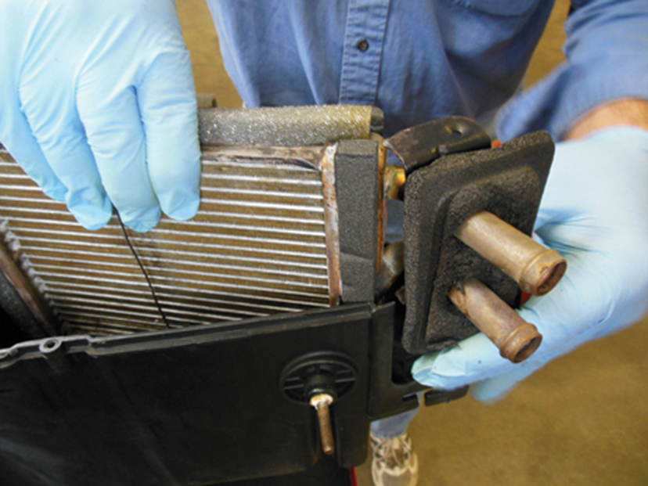

2. Check the service information and determine the specified procedure for filling the cooling system and bleeding the air after the heater core replacement. (List the procedures)
______________________________________________________________________________
______________________________________________________________________________
3. How much coolant is required to refill the system? ____________________________________
______________________________________________________________________________

