1. Check service information for the specified procedures to follow to test the heater
Evaluation (Enter number from 4, 3, 2, 1) :_________

Meets ASE Task: A7 – C-2 – P-2
Time on Task:_____________
Make/Model/Year:____________________________________
VIN:_________________________________
Date:_____________
Name:_____________________________________
Heater System Service
control valves.
______________________________________________________________________________
______________________________________________________________________________
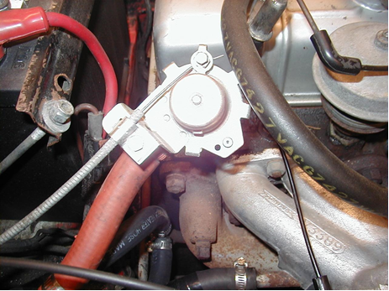

2. Based on the inspection of the heater control valve(s), what is the necessary action?
______________________________________________________________________________
______________________________________________________________________________
3. Remove and install heater core as needed.
______________________________________________________________________________
______________________________________________________________________________

