1. Check the level of coolant in the coolant recovery tank. It should be between the “full
Evaluation (Enter number from 4, 3, 2, 1) :_________

Meets ASE Task: A7 – C-1 – P-1
Time on Task:_____________
Make/Model/Year:____________________________________
VIN:_________________________________
Date:_____________
Name:_____________________________________
Cooling System Inspection
hot” and “full cold” lines. OK _______ NOT OK _______
2. After the engine has cooled, remove the radiator cap.
CAUTION: Do not remove the radiator cap if the engine is hot. The coolant will explosively expand when the cap is removed which can cause severe burns to anyone near the vehicle.
3. The coolant should be at the full level in the radiator.
OK _______ NOT OK _______
4. Check the freezing point and boiling point of the coolant.
Freezing point = ___________ [should be -34° F (-36° C) or lower]
Boiling point = ___________
5. Pressure test the cooling system by installing a cooling system pressure tester and pump until
the pressure is equal to the pressure cap value. Pressure should hold if there are no leaks.
OK _______ NOT OK _______
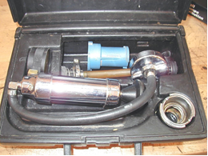
6. Test the radiator cap using the cooling system pressure tester with an adapter that fits the cap.
The cap should hold its rated pressure. OK _______ NOT OK _______
7. What is the necessary action? _____________________________________________________
______________________________________________________________________________

