1. Check service information for the recommended coolant testing, recover, flushing, and
Evaluation (Enter number from 4, 3, 2, 1) :_________

Meets ASE Task: A7 – A-1 – P-1
Time on Task:_____________
Make/Model/Year:____________________________________
VIN:_________________________________
Date:_____________
Name:_____________________________________
Test and Replace Coolant
refilling procedures. _____________________________________________________________
______________________________________________________________________________
______________________________________________________________________________
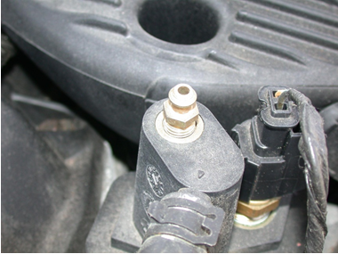

2. What is the recommended coolant? ________________________________
3. Is the cooling system equipped with bleeder valves to help with bleeding trapped air
from the cooling system when it is refilled?
______ No ______ Yes (describe location) _________________________________________
_____________________________________________________________________________
_____________________________________________________________________________

