1. Check the operation of the heating and ventilation door system. Describe the operation

Evaluation (Enter number from 4, 3, 2, 1) :_________

Meets ASE Task: A7 – D-6 – P-2

Time on Task:_____________

Make/Model/Year:____________________________________

VIN:_________________________________

Date:_____________

Name:_____________________________________

**HVAC Ducts and Doors**

and/or faults detected. __________________________________________________________

______________________________________________________________________________

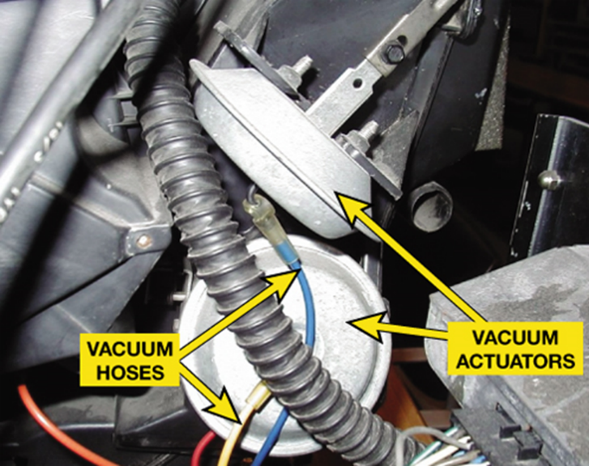

2. Based on the inspection, what is the necessary action? ________________________________

______________________________________________________________________________

______________________________________________________________________________

