1. Check for proper operation of the vacuum, mechanical, and electrical components and
Evaluation (Enter number from 4, 3, 2, 1) :_________

Meets ASE Task: A7 – D-5 – P-2
Time on Task:_____________
Make/Model/Year:____________________________________
VIN:_________________________________
Date:_____________
Name:_____________________________________
A/C and Heater Controls
controls of the HVAC system. Describe the operation and/or faults detected.
_____________________________________________________________________________
_____________________________________________________________________________
_____________________________________________________________________________
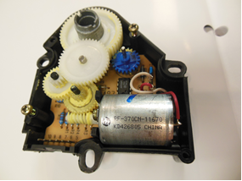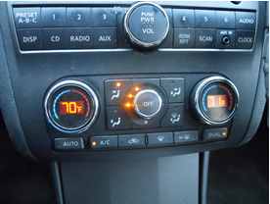

2. Check the operation of the A/C heater control panel assembly. Describe the operation
and/or faults detected. ______________________________________________________
__________________________________________________________________________
3. Check the operation of the AC heater control cables (if equipped) and motors.
Describe the operation and/or faults detected. ___________________________________
__________________________________________________________________________
4. Based on the inspection, what is the necessary action? _______________________________
__________________________________________________________________________
__________________________________________________________________________

