1. Check service information and describe the specified procedures to follow to diagnose
Evaluation (Enter number from 4, 3, 2, 1) :_________

Meets ASE Task: A7 – D-1 – P-1
Time on Task:_____________
Make/Model/Year:____________________________________
VIN:_________________________________
Date:_____________
Name:_____________________________________
HVAC Electrical Controls
HVAC electrical control faults. _____________________________________________________
______________________________________________________________________________
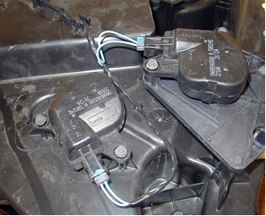

2. Check all the test equipment specified that is needed to diagnose HVAC electrical
control faults.
______ a. DMM
______ b. Scan tool
______ c. Special tester (describe) ____________________________________
______ d. Other (describe) __________________________________________

3. After diagnosis following the specified procedures, what is the necessary action?
______________________________________________________________________________
______________________________________________________________________________

