1. Check service information on how to gain access to the front side of the condenser

Evaluation (Enter number from 4, 3, 2, 1) :_________

Meets ASE Task: A7 – B-11 – P-2

Time on Task:_____________

Make/Model/Year:____________________________________

VIN:_________________________________

Date:_____________

Name:_____________________________________

**Inspect the Air Conditioning Condenser**

(describe what needs to be done).

______________________________________________________________________________

______________________________________________________________________________

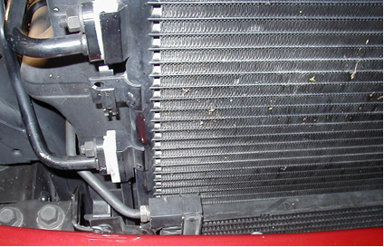

2. What is the recommended method and/or tools needed to clean the condenser?

_____________________________________________________________________________

_____________________________________________________________________________

3. Based on the inspection, what is the necessary action?

_____________________________________________________________________________

_____________________________________________________________________________

_____________________________________________________________________________