1. Check service information and determine the recommended procedure for removing and inspecting the air conditioning hoses, lines, O-rings, seals, mufflers, and fittings for leaks or other failures. __________________________________________________________________

Evaluation (Enter number from 4, 3, 2, 1) :_________

Meets ASE Task: A7 – B-6 – P-2

Time on Task:_____________

Make/Model/Year:____________________________________

VIN:_________________________________

Date:_____________

Name:_____________________________________

**Inspect A/C System Hoses, Lines, O-Rings & Fittings**

______________________________________________________________________________

______________________________________________________________________________

2. Using the recommended procedure perform the needed inspections. _____________________

______________________________________________________________________________

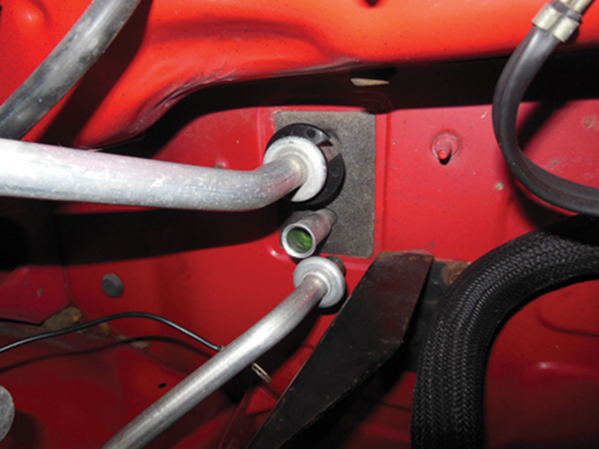

3. Based on the inspections, what are the needed repairs? ________________________________

______________________________________________________________________________

______________________________________________________________________________